|  |
| --- |
| 3-27-2017 |

|  |
| --- |
| Abno Software International |
| USER MANUAL |
| Version 0.0.1 |

Contents

MICROBIOLOGY USER MANUAL 3

i. INTRODUCTION 3

ii. PROCESS OVERVIEW. 4

Common Icons and what they mean 5

PROCESS WORKFLOW 6

1. Micro Sample Preparations 6

1.1. Logging in 6

1.2. Add PT Managers. 7

1.3. Labs. 8

1.4. Users 9

1.5. Add new Laboratory Manager 9

1.6. Samples. 11

1.7. Packaging 19

1.8. Shipments 23

1.9. Rounds. 30

1.10. Extras 34

2. Micro-Reports 36

2.1. Evaluation 36

2.2. Publish. 40

2.3. General 41

2.4. Analysis. 43

3. User/Laboratory Login. 45

3.1. Login Process 45

3.2. Dashboard. 47

3.3. Shipments. 49

3.4. Sample issuing 52

3.5. Results 54

3.6. My account 58

3.7. Logout 59

# MICROBIOLOGY USER MANUAL

## INTRODUCTION

This module allows the for PT testing on microbiology on different labs across the country

In the microbiology modules, it contains majorly 2 parts,

1. Administration sub-module.

The admin side where the admin user gets to create the test samples, rounds, grading etc.…

1. The lab/participant sub-module.

Here the participating lab gets to view the received samples and enter the results and give back their results.

## PROCESS OVERVIEW.

Firstly, the PT admin get to log into the system and will then create the samples, the samples are then packages into packages, the packages are then added to shipments which he/she should have created prior.

On addition to that the user creates a round of testing, once the round has been created he/she add shipments and participating labs to the rounds.

Once everything has been correctly set up, the round can then been started.

It’s important to note that every step is necessary otherwise no round can be started if an of the step is skipped

Basic description of the steps

* Log in.
* Add labs.
* Add lab user who can log in.
* Map users to labs
* Create samples
* Create panels.
* Add samples to panels.
* Create shipments
* Add panels to shipments
* Create rounds
* Add shipments to rounds
* Add labs to rounds
* Start round
* Wait for the results to be evaluated

At the lab level.

* User logs in.
* Receives the sent shipments
* Issues sample to user(which can be himself/herself)
* The user takes the test and fills a form with his/her results
* The submits
* After the results have been evaluated, the user can be able to view the results.

### Common Icons and what they mean

* Print Barcode
* Lock/deactivate item
* Delete item
* Edit Items
* Show detailed and wider view
* Show extra information/add instructions
* refresh or fetch data for the current page
* Add items to the current time
* Export to excel
* Print pdf

## PROCESS WORKFLOW

## Micro Sample Preparations

### Logging in

Before any user can access the system, he/she must login in, as shown in the image below.

Please enter the correct email and password or else you won’t be able to login.

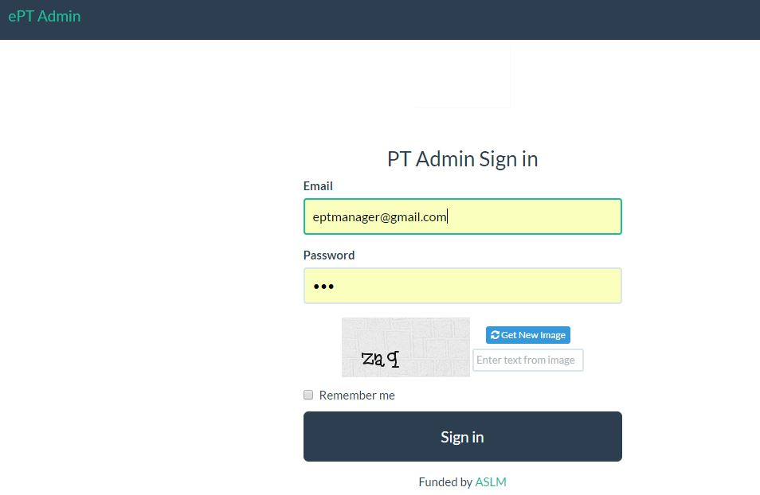

Figure 1

On successful log in ,menus will appear on the top and will land on the below homepage.

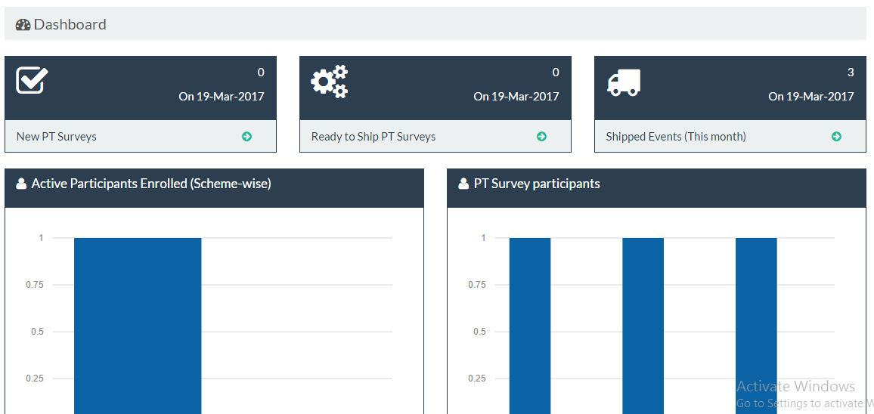

Figure 2

### Add PT Managers.

On the configure menu dropdown, click on Admin manager.

You will see the below page, click on the circled button to add a new Admin Manager

The available ones also appear hereto edit an available PT manager, click on the edit button on every row.

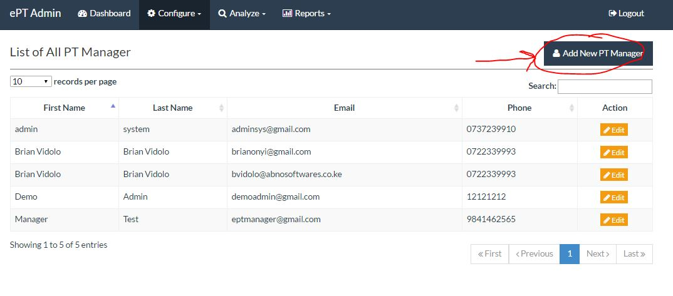

Figure 3

The below form appear, please fill all the fields marked us mandatory.

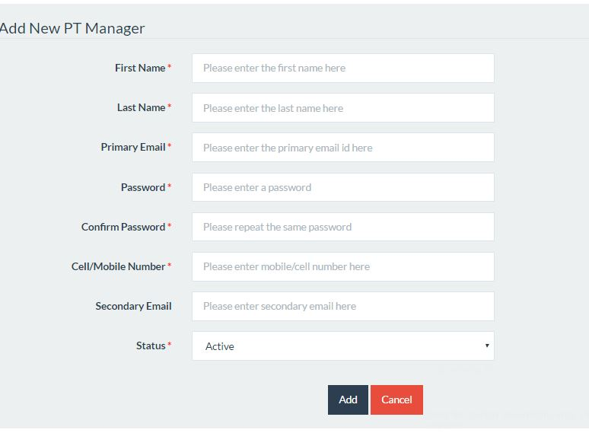

Figure 4

### Labs.

From the configure menu, click on the micro labs.

To add a new lab click on the circled button. This page also shows all available labs. To edit an existing click on the edit button.

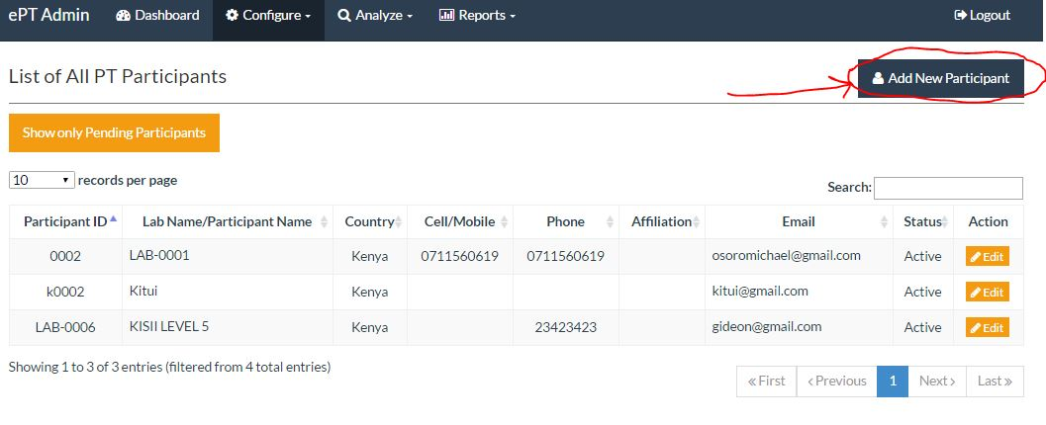

Figure 5

### Users

From the configure down drop, click on users, figure 6 below appears

##### View/edit Laboratory Managers

To edit a user, click the edit button on each row

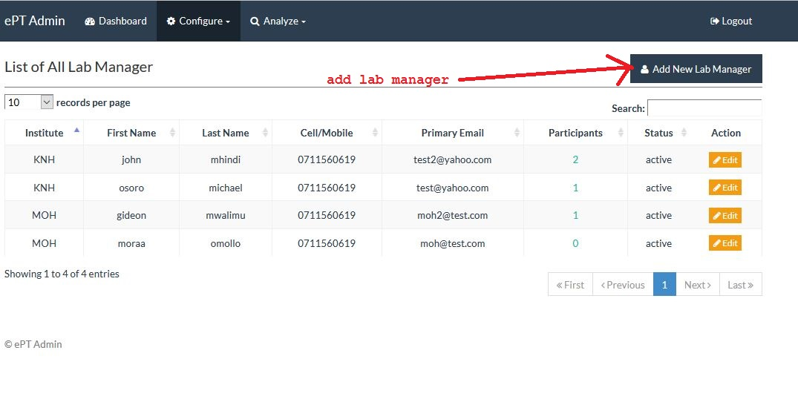

Figure 6

### Add new Laboratory Manager

On view part once the add new lab manager button is clicked, the below form appears. Please fill the fields marked with red

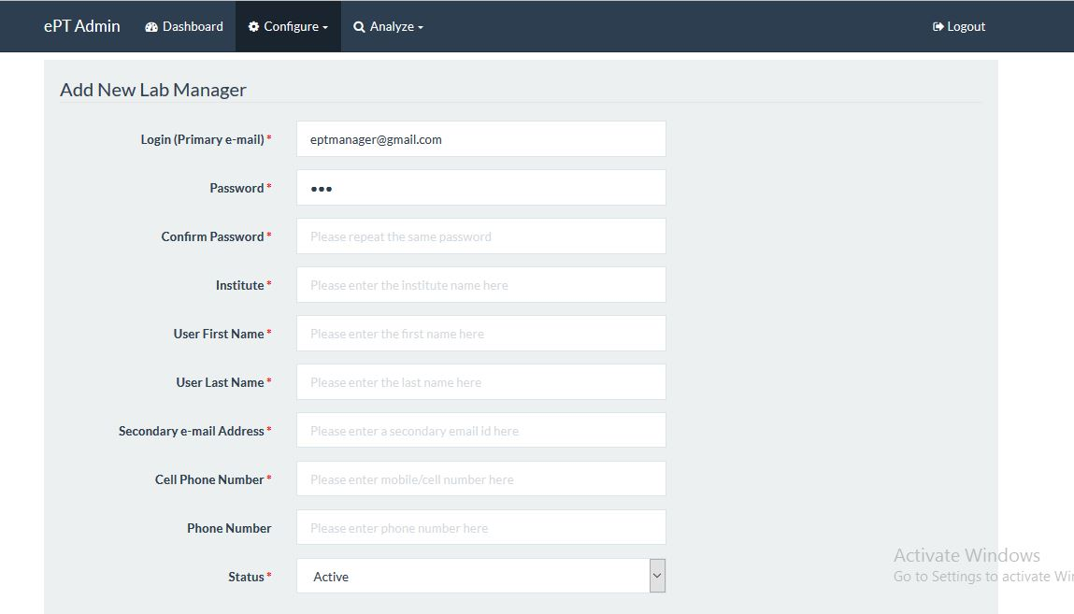

Figure 7

##### Lab and user mapping.

From the configure drop down, click on lab & user mapping, the below page occurs.

To map a user to a lab, choose a lab on the left, the current users not on that lab appear. On

The right users already enrolled on that lab also appear, click on a user to mode or remove

User from the lab i.e. click user on the left adds the user to a lab, click on the user on the left

Removes the user from the lab.

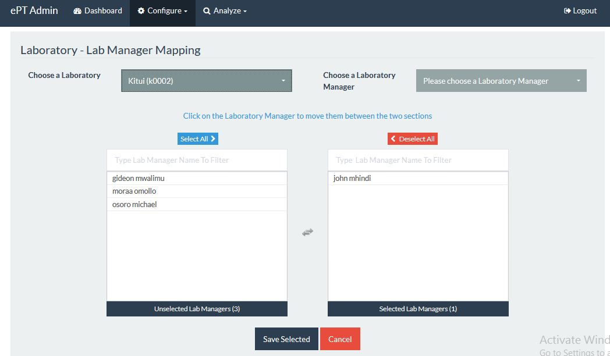

Figure 8

### Samples.

From the main menu, click on configure then click on micro-biology. The page represented by the figure 9 appears.

Figure 9 demonstrates and shows all the button on it and what they do. It’s important to note that ,you have to click  to load/refresh data.

##### Edit/delete and view samples

To edit or delete please click on the edit and delete buttons respectively.

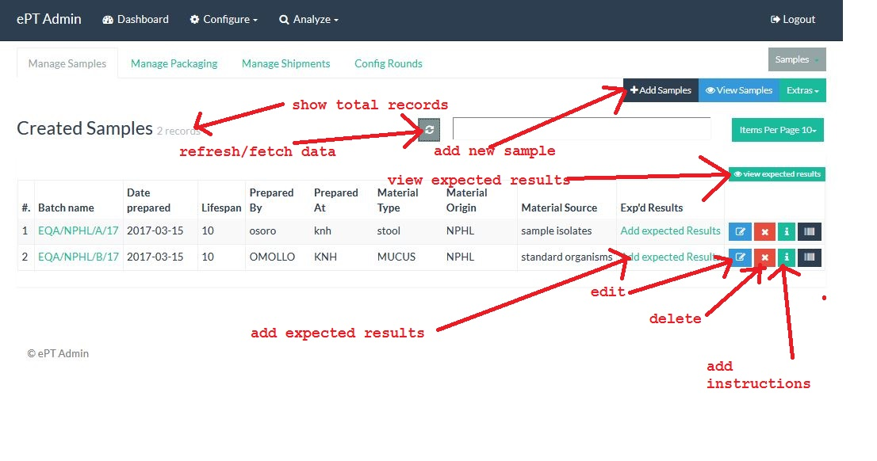

Figure 9

##### Add Samples

Once the add samples button on the top is click figure 10 appears, please fill all the fields then click save , you will be redirected to the main/view samples page.

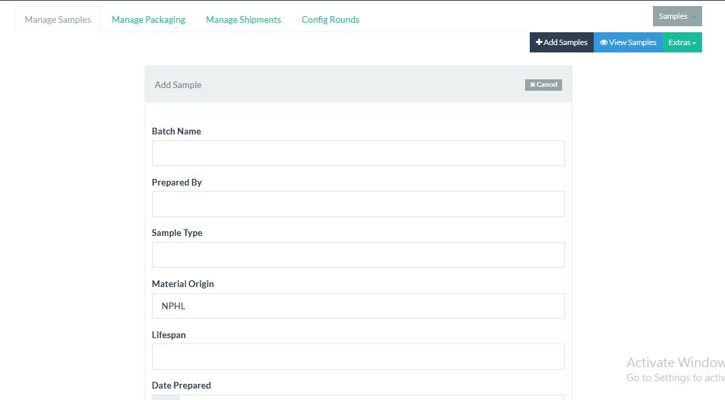

Figure 10

##### Add/edit/view sample instructions

Click on the add instructions as labelled on figure 9,below form appears, by default its filled, please edit the form where necessary and click save to save the form

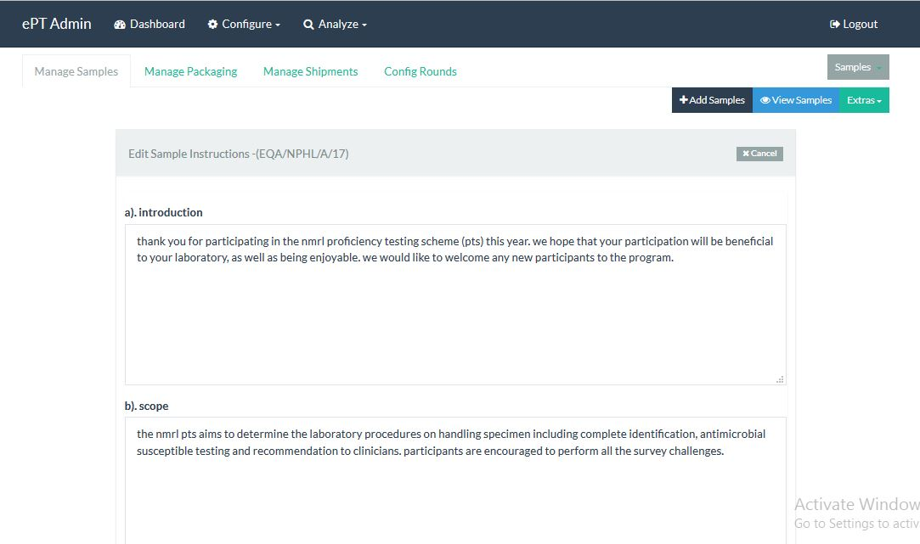

Figure 11

##### Add/edit expected results data/view

Click on the add expected results link, below form appears ,fill the fields and click save, this are the results that will be used to evaluate the labs

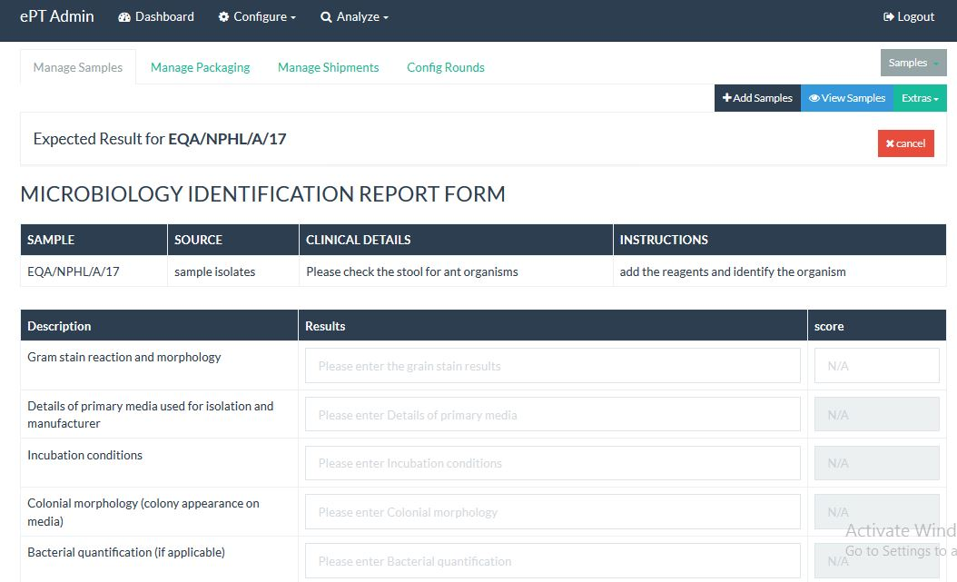

Figure 12

##### Sample grading

On the Extras menu click on grades ,the add grade appears

###### Add grades.

On this section the, this is the grade that the user will be awarded based on the point he/she could have scored. The admin is supposed to fill the grade name and the range within which the grade appears.

NB : please do not use overlapping grades, incase overlapping grades are added only the first one will be user.

On the name fill like UNACCEPTABLE, range fill the lower limit e.g. 0 and upper fill 75 so any user who scores between 0-75 will be regarded as UNACCEPTABLE.

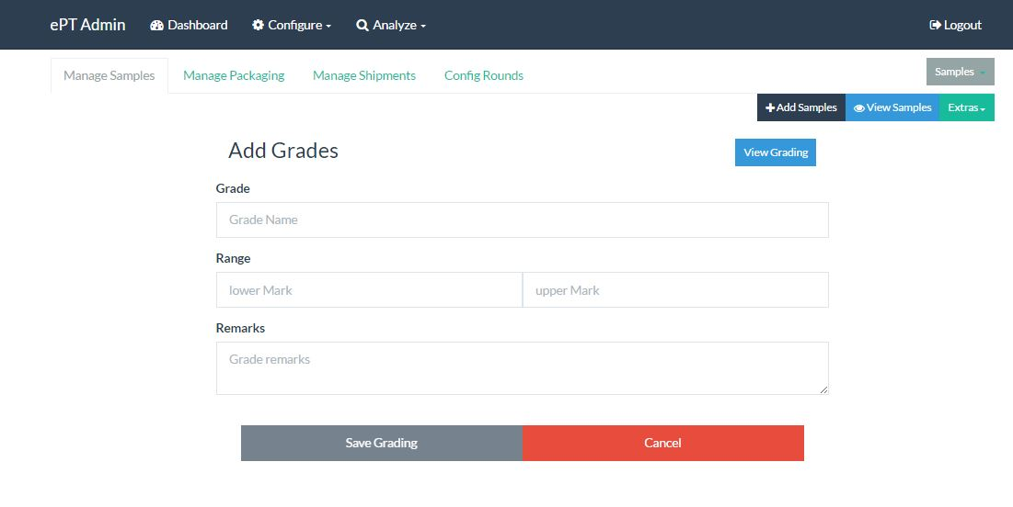

Figure 13

###### View Grades.

On top of the add grade form click on the view grades.

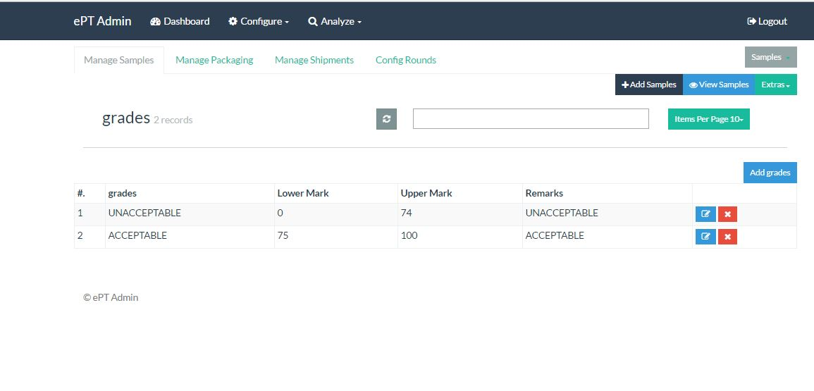

Figure 14

##### Reagents

Test reagents /organisms these present the items used for testing purpose. The system allow the admin to ass unlimited number.it however comes with preloaded organisms.

On the extras drop down, click on the test reagents. The below form appears

* + - 1. Add Test reagents

Fill all the fields and click save micro agent button.

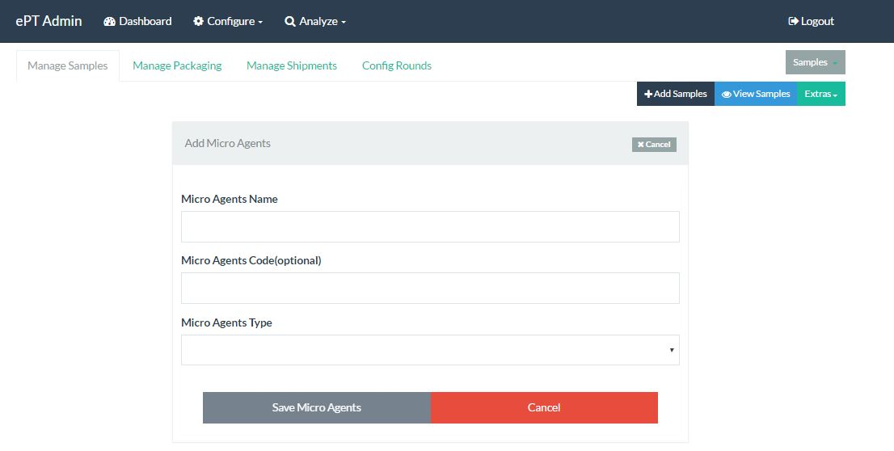

Figure 15

* + - 1. View Test reagents

On adding an organism, you will be re-directed to the view all micro agents page,

Also on top of the adding form, you can click on cancel and you will be re-directed to the view organisms page.

To edit or delete a row, please click on the edit and delete button respectively..

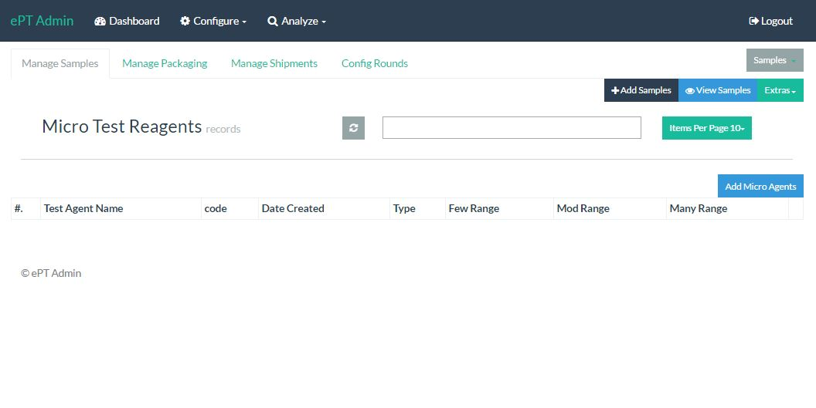

Figure 16

##### Sample types.

###### Add sample types

This presents the type of sample type of testing

On the extras menu click on the test types, the below form appears.

To view sample test types, click on the view test types button on top of the form, figure 18 appears

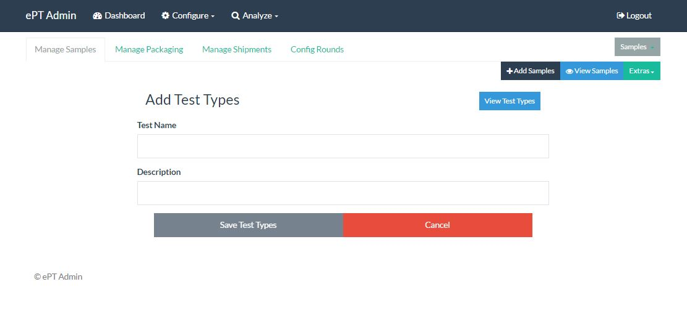

Figure 17

###### View Sample Type

To edit or delete a sample test type, click on the and delete buttons respectively.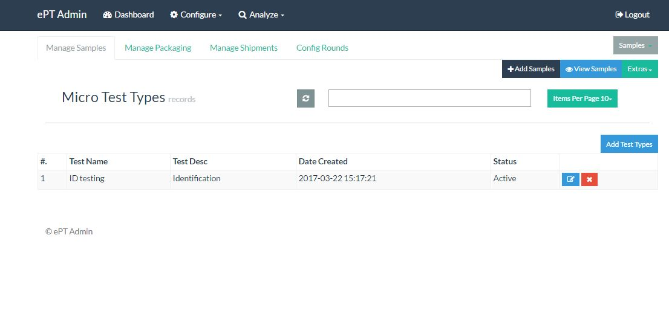

Figure 18

##### View Sample Summary.

Sample summary presents based on participatory, response and results on a particular sample

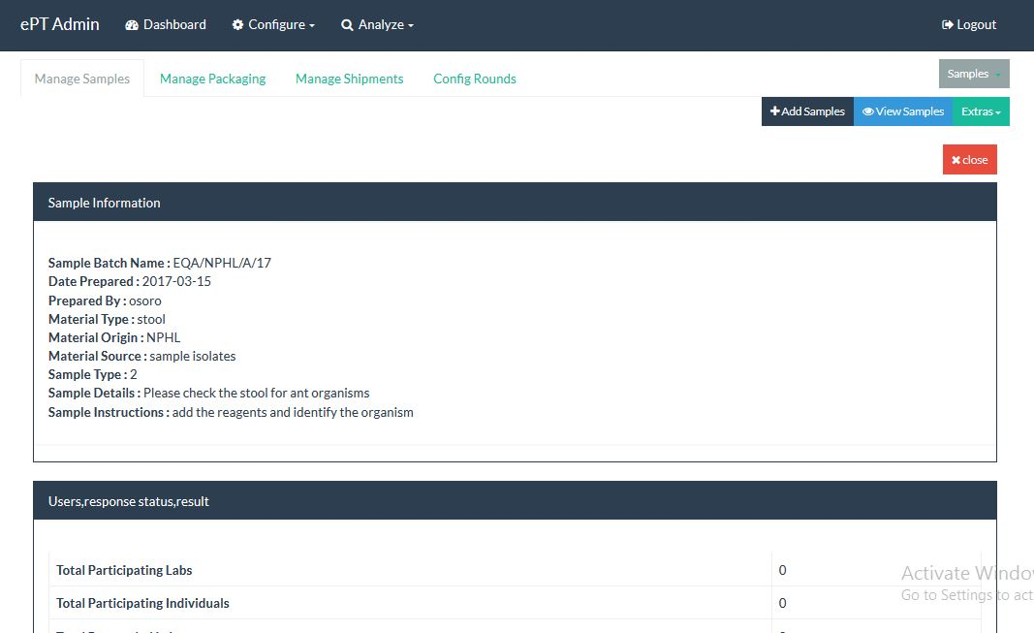

Figure 19

### Packaging

On the tabs section , click manage packaging,

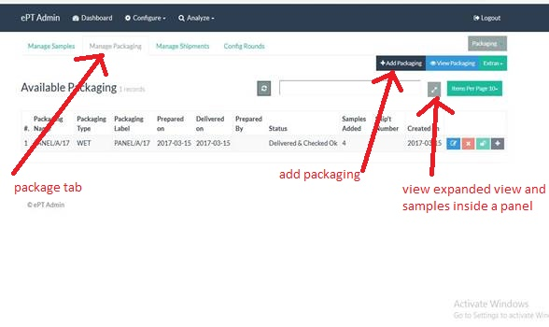

Figure 20

##### Add/edit/delete and view packages.

The below image is loaded as the default packaging page.to add a package,

To edit or delete a package, click on the edit and delete buttons respectively

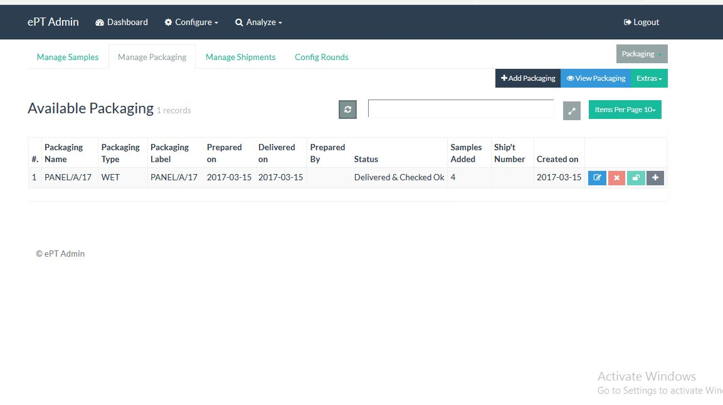

Figure 21

##### Add Package.

Click on the add button just below the tabs menu as illustrates by the figure 19.

Below form appears, fill in all the click the save package button. This will then re-direct to the main package page.

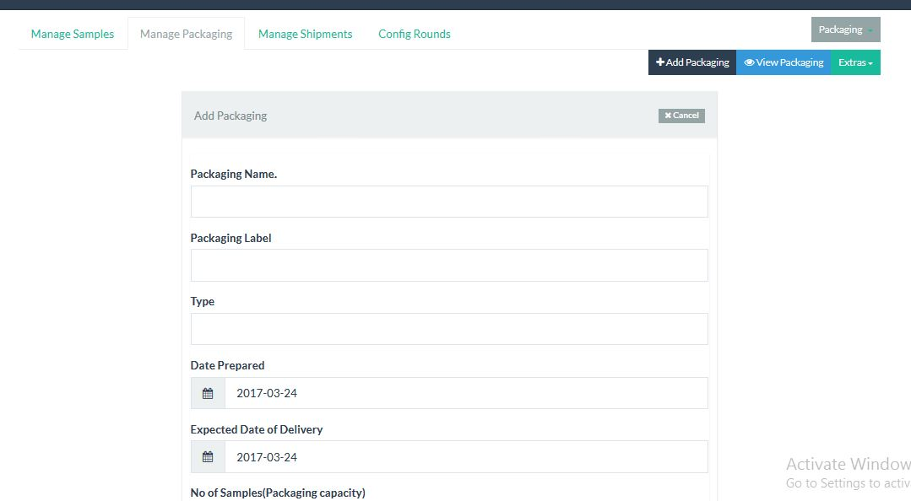

Figure 22

##### Add samples to panels to package

The admin has to add samples to the created packages for them to be able to be shipped out.

As illustrated on figure 20, click on the add button from the main package page,

The below form appears. If no panels have been loaded, click on the refresh button.

Samples appear here, but default a quantity of one is allowed. On the far left on the table tick on a sample to add it to the package then save samples to package (package name).

NB : you cannot add the same sample twice to the same package, an error message will be generate,

If you want to add it again, you will first delete it from the package then add it again.

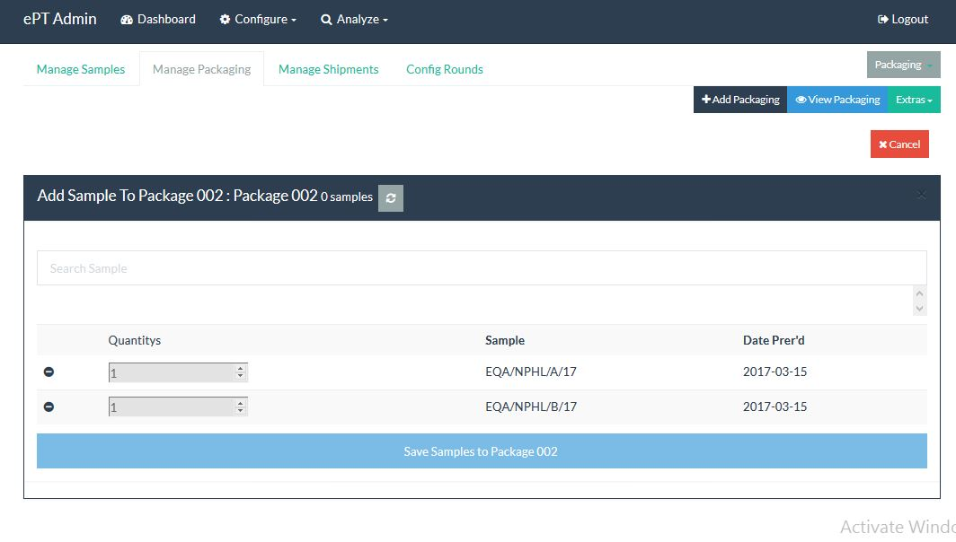

Figure 23

##### View samples in a package

Click on the expand button as illustrated on figure 20,the below page will appear, click on the package name to expand it.

All the samples inside the panel will appear on the right.

It’s important to note that a package cannot be sent with samples inside

And a sample cannot be sent without being attached to a sample.

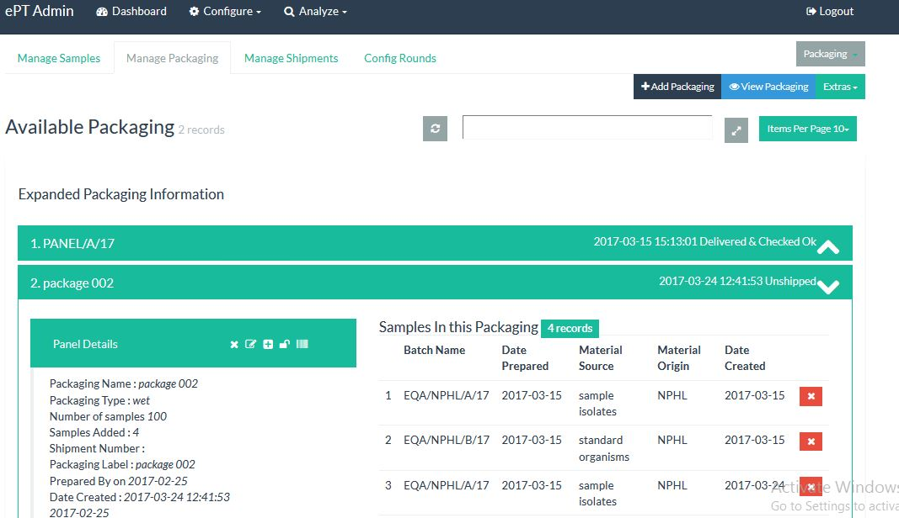

Figure 24

### Shipments

Shipments holds everything involved in sample preparation, packages, it’s from shipments where you dispatch/send to users.

A shipment cannot be dispatched without panels inside.

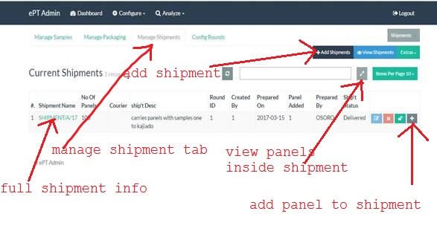

Figure 25

##### Edit/delete and view

To edit or delete a shipment click on edit and delete buttons respectively.

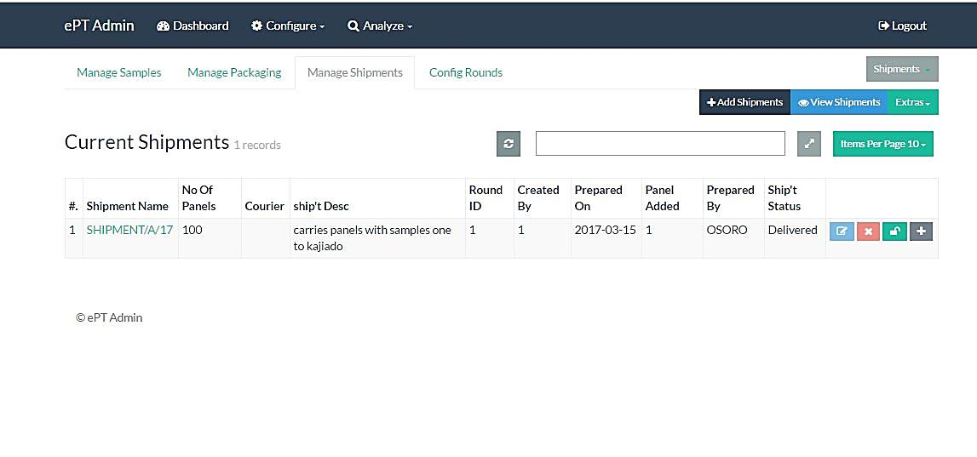

Figure 26

##### Add Shipment.

To add a shipment click on the add shipment button as illustrated above

Below form appears, fill all the fields and click save shipment. On successful saving a message appears.

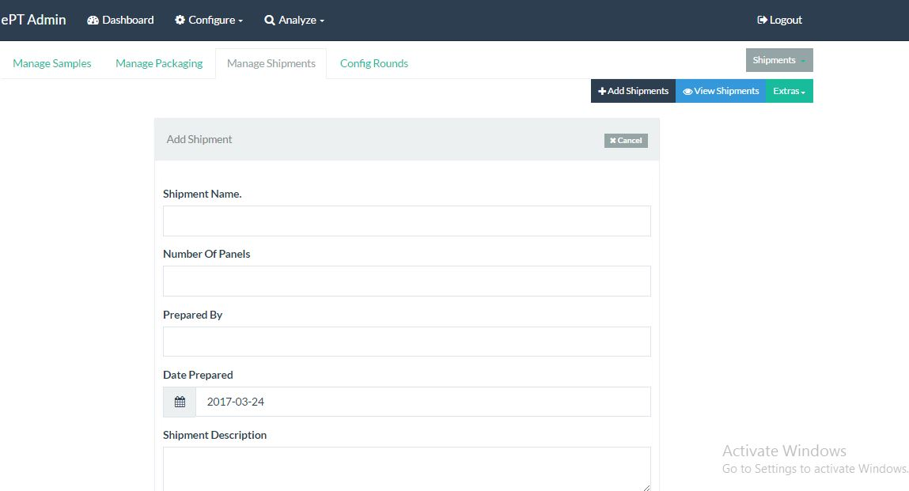

Figure 27

##### View/panels to/on shipment.

Click on the expand button as illustrated on figure 25.Below page appears, click not eh shipment name show full detail.

On the left side it shows all the packages that are currently inside the shipment. You can click on the delete button to remove a package.

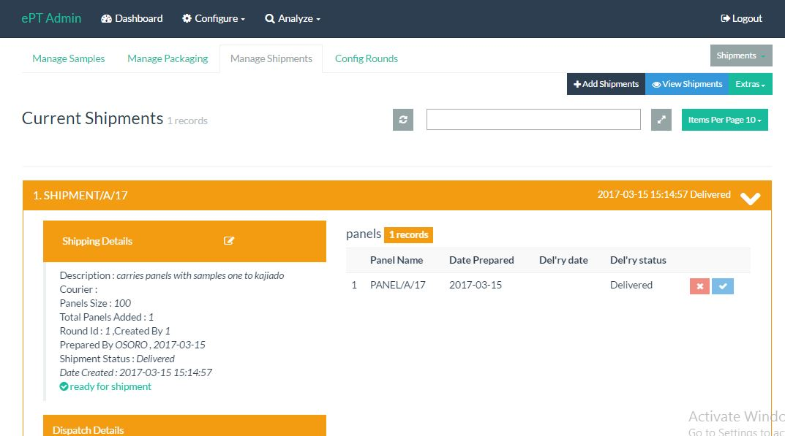

Figure 28

##### Add panels shipment

Click on the add button, the below table appears.

If not panels are on the table, click on the refresh button. On the left tick the checkbox to add the packages. Click on save panel to shipment button.

To be able to save, you must add at least one package.

It’s important to note that you cannot add the same package twice to the same shipment.

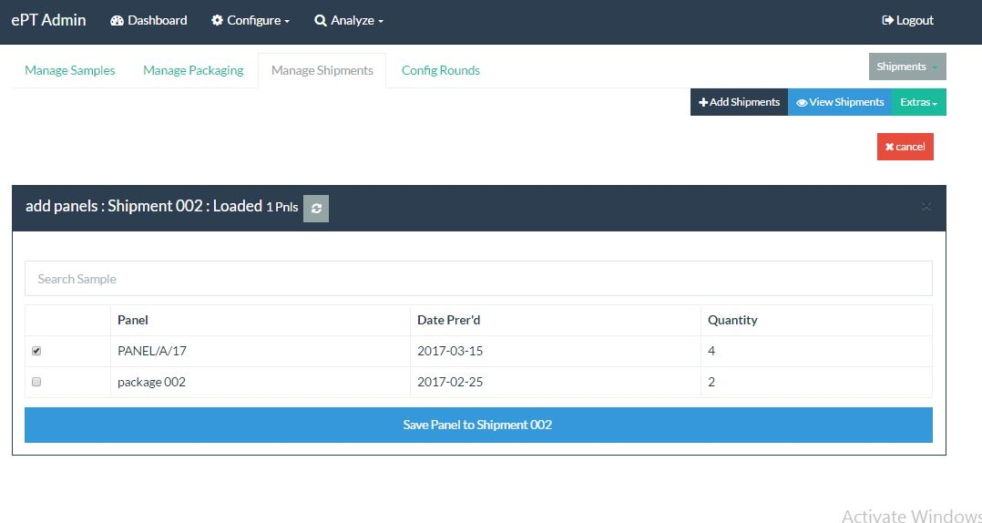

Figure 29

##### Shipment Full Information.

A shipment contains packages, shipping information, samples inside packages.

Click on the shipment link as illustrated by figure 25 the below page appears.

If you wish to print ,click on the print link on the top right.

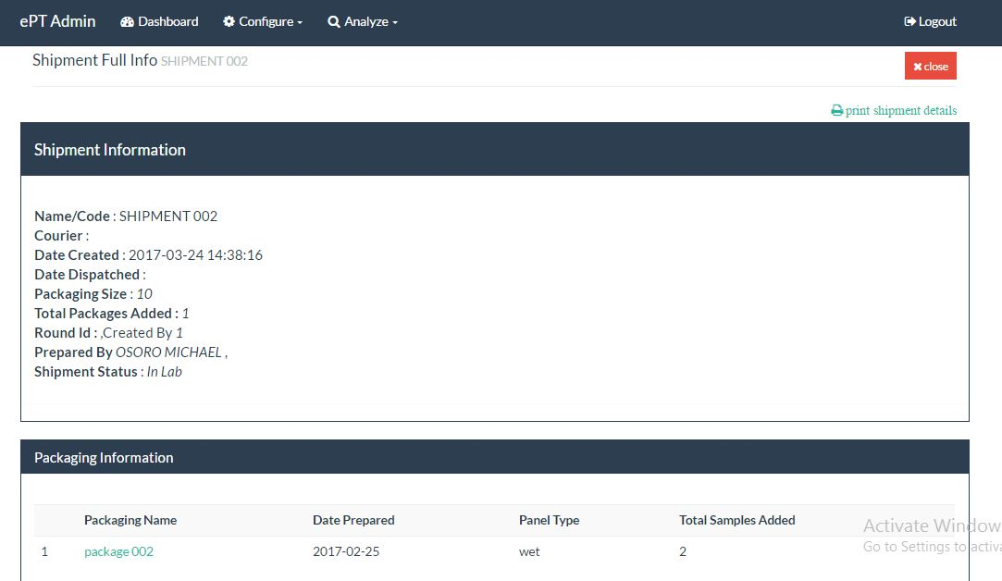

Figure 30

##### Dispatch Shipment.

From the expanded, click on the shipment name to expand it.

On the shipment details click on the button as illustrated below.

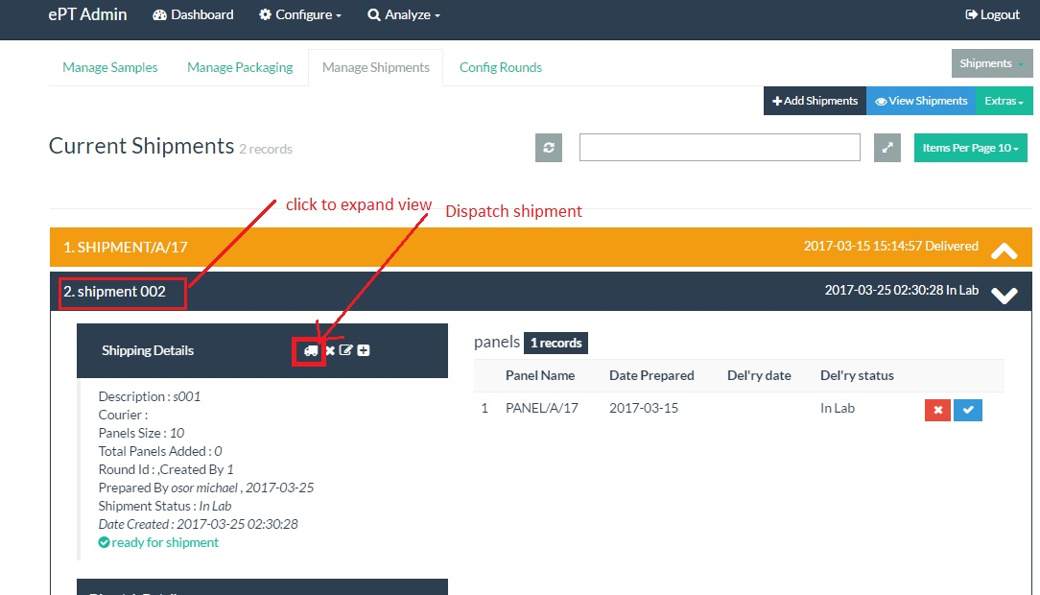

Fill the form below and click dispatch. Once a shipment has been dispatched you cannot delete the packages in it or cancel the dispatch

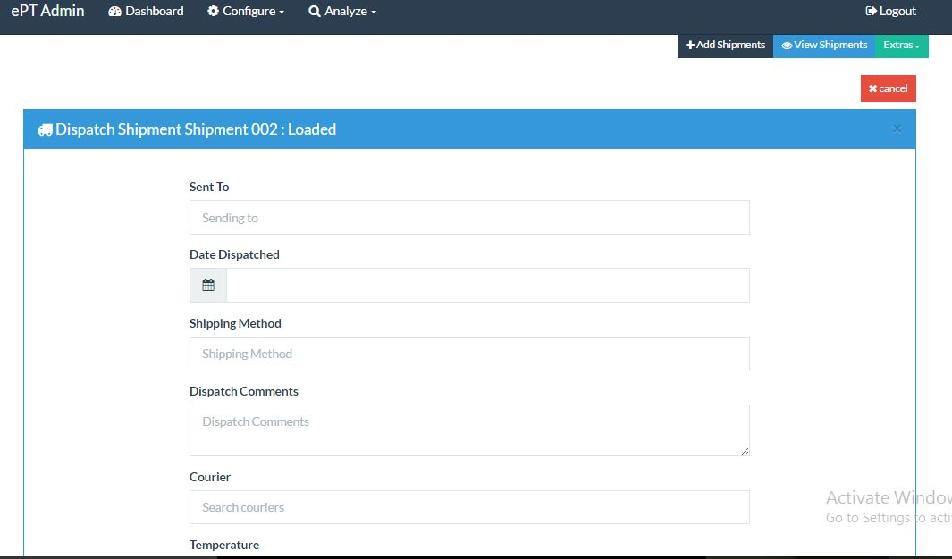

Figure 31

### Rounds.

Every round that takes place is configured from this place,

On the tabs menu click manage rounds as illustrated below.

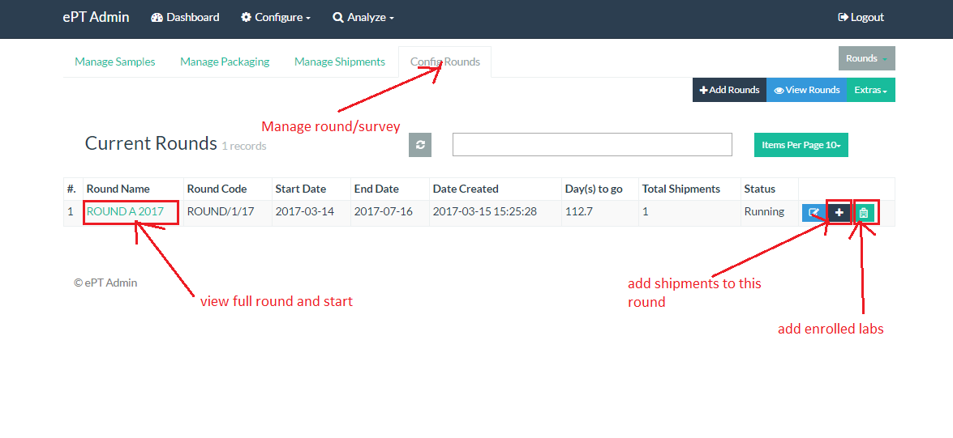

##### Edit and view.

To edit a round, click on the edit button.

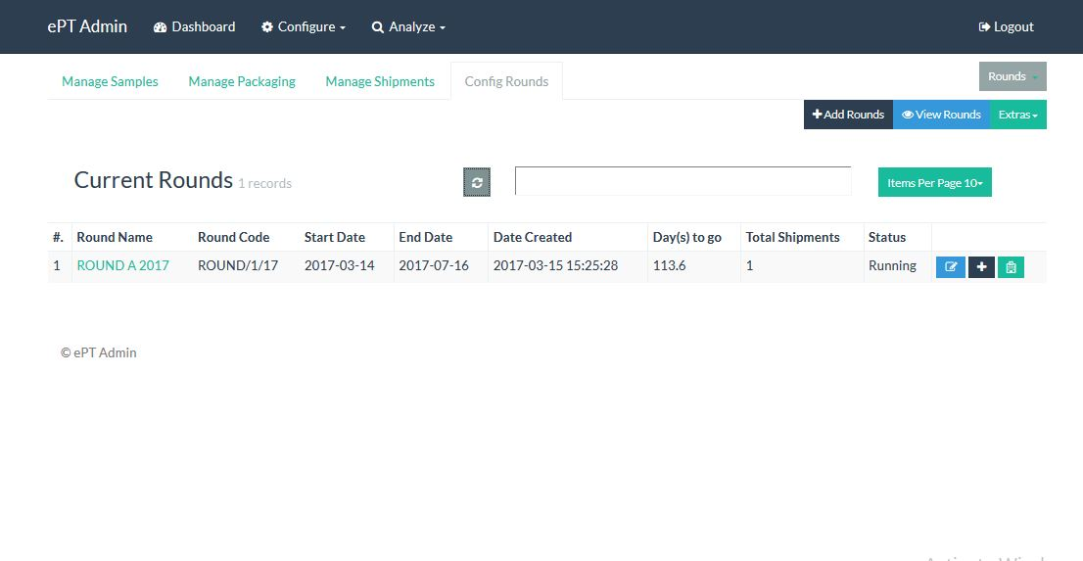

Figure 32

##### Add Round

Please fill the fields and click save.

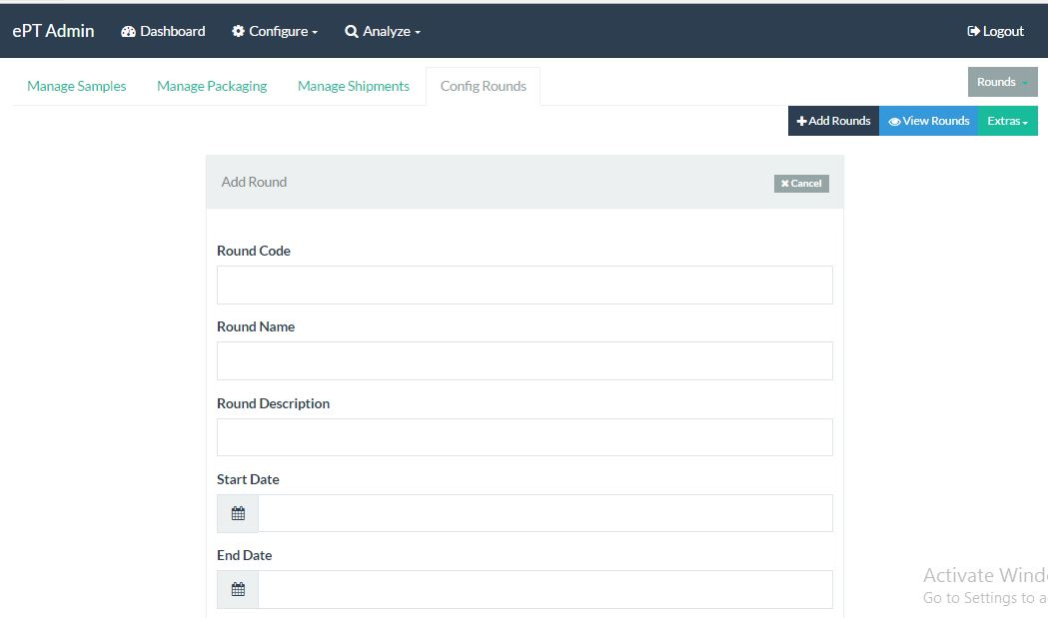

Figure 33

##### Add shipments to rounds.

Click on the add shipments button as illustrated above.

The page below appears. Tick the shipment you want to add to the round and click save shipment.

A notification message will appear when successfully added to a round

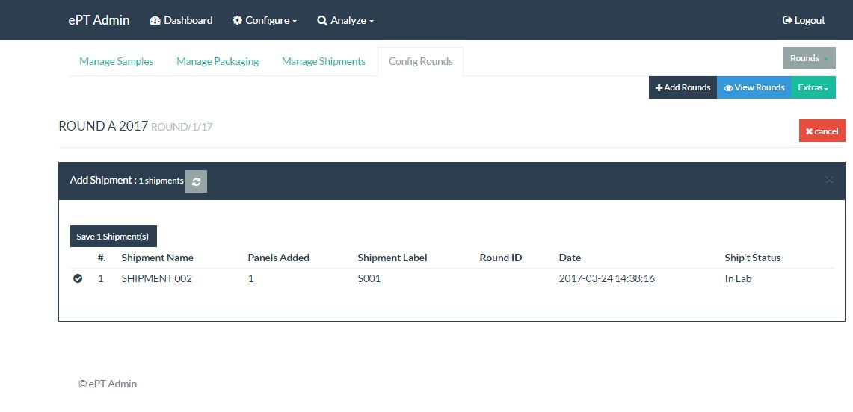

Figure 34

##### Enroll lab for the round.

All labs that will participant in the upcoming round will appear here.

The admin will then add the labs he/she wishes to participant in the current round and click save.

Every lab added will receive a piece of the sample added to the package.

A lab cannot be added twice to a round.

This feature cannot be undone ,since an email notification is sent when a lab is enrolled for a round.

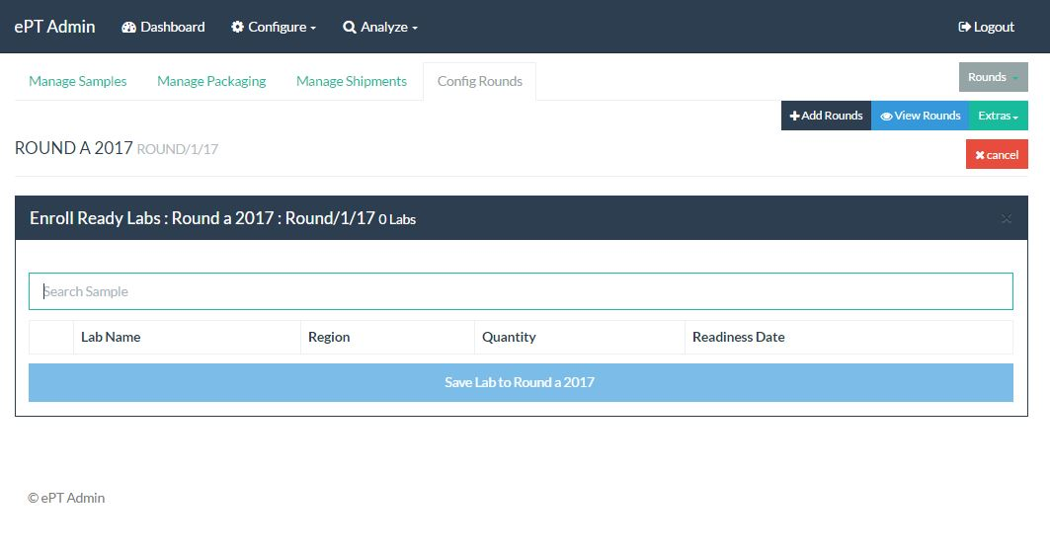

Figure 35

##### Start Round.

Click on the round the round link, it will open the below page,click on te button at the bottom of the page and confirm

NB : You can only be able to start a round once a if you have added lab and shipment to the round.

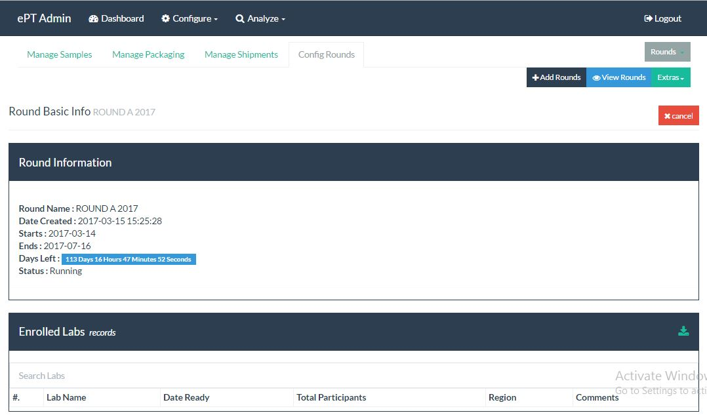

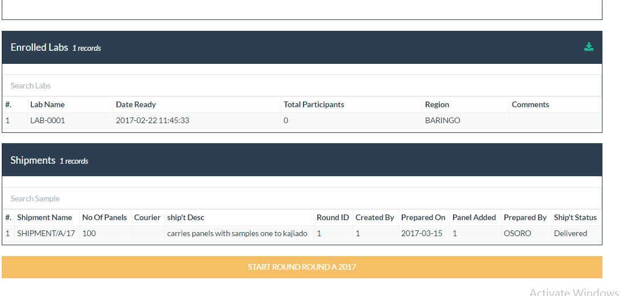

Figure 36

### Extras

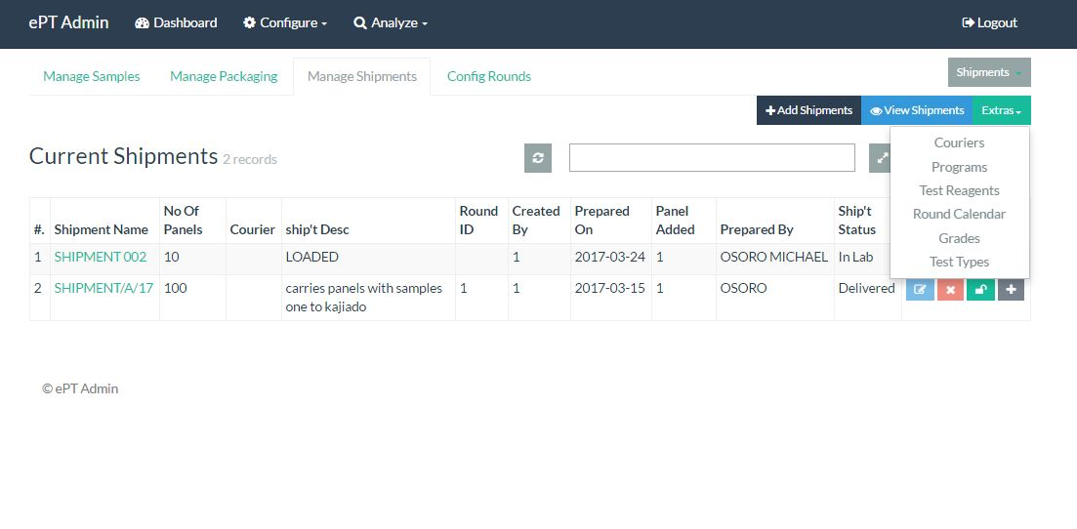

Figure 37

##### Couriers

Click on couriers from the extra menu,

You can edit or delete a courier by click respective buttons

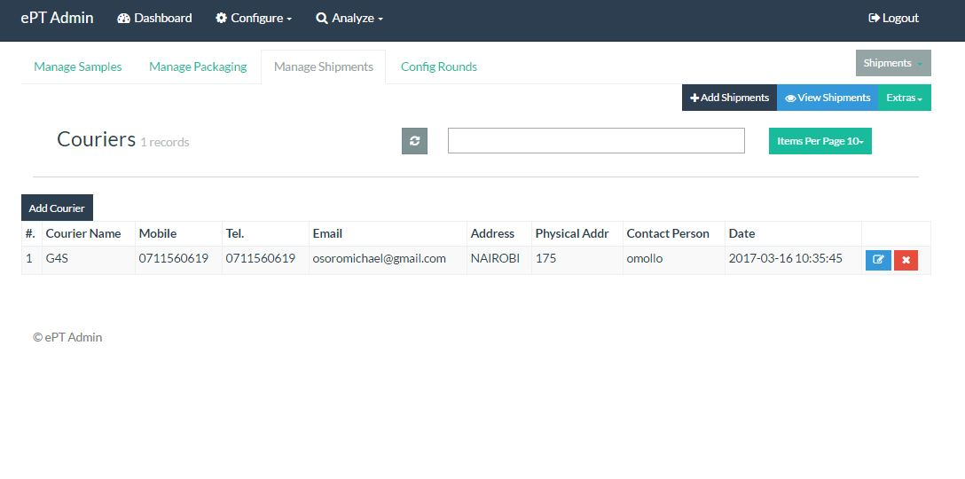

Figure 38

##### Add courier.

From figure 38 above clicking on the add courier module, the below appears form appears , fill or the fields and click save.

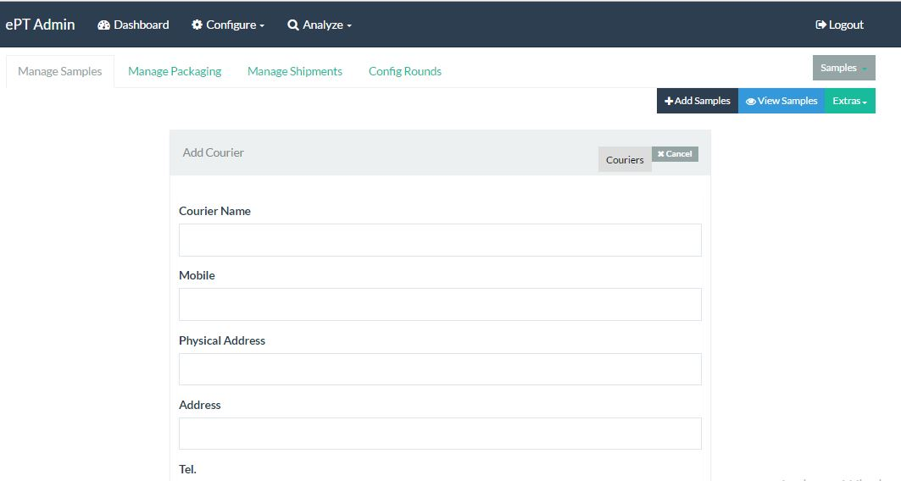

Figure 39

## Micro-Reports

On the main menu click on analyze, you will land on the below page illustrated by figure 40.

The evaluation tab is selected by default.

### Evaluation

Evaluation of user feedback is usually happens here.

##### Round Evaluation.

Evaluation will award marks and comments to the participants. Evaluation cannot be done unless the end of the round has reached.

Evaluation is not possible if no participant has responded to the survey.

##### Round

The admin can evaluate the whole round at once by clicking the round evolution from the evaluation tab. He/she however, has an option of narrowing down to a shipment by click on the round name.

The admin has to select the date range for the rounds and click get report

Click on the evaluate/re-evaluate button

Figure 41 shows the page loaded, on the top part of the table click evaluate/re-evaluate round button as illustrate.

Confirm to evaluate round

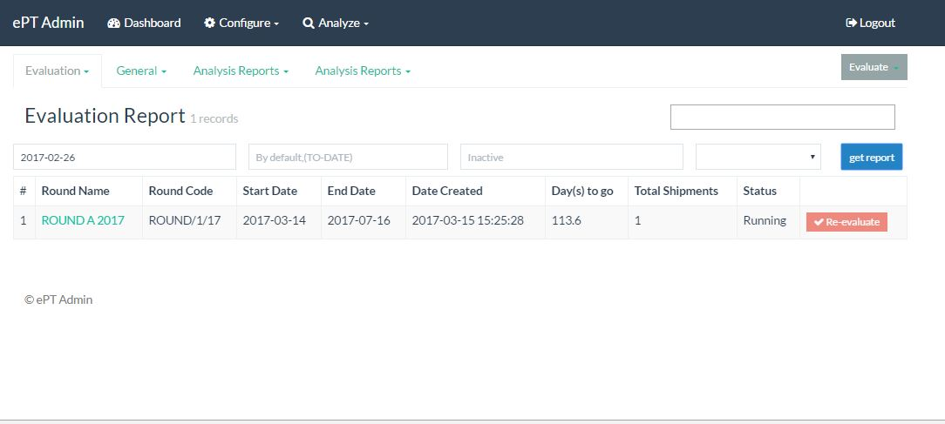

Figure 40

##### Shipment

Clicking on evaluate/re-evaluate button open the below page ,a pop up of confirming whether you want to proceed appear. Confirm to evaluate.

There is no limited number one can evaluate a round or a shipment. After the first evaluation, a re-evaluate button will be appearing.

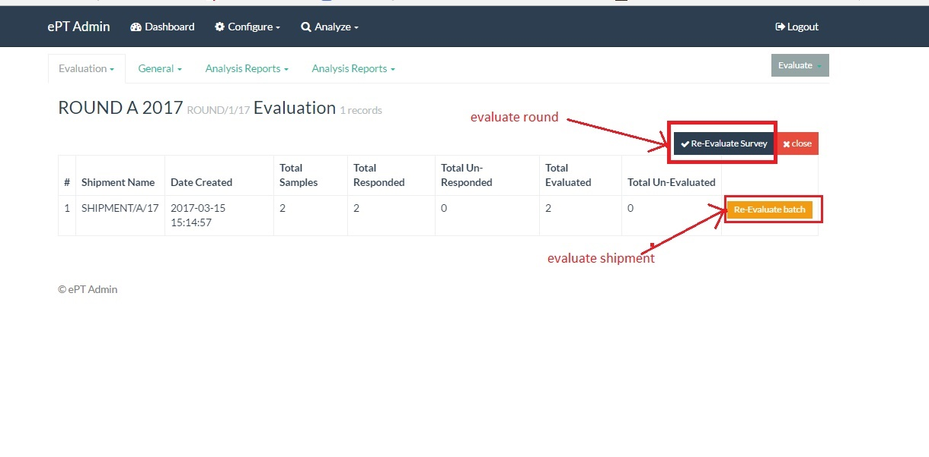

Figure 41

##### Individual Evaluation.

If the admin feels that the participant needs special evaluation this is also allowed, the admin can also do an individual evaluation by awarding the marks out of the system evaluation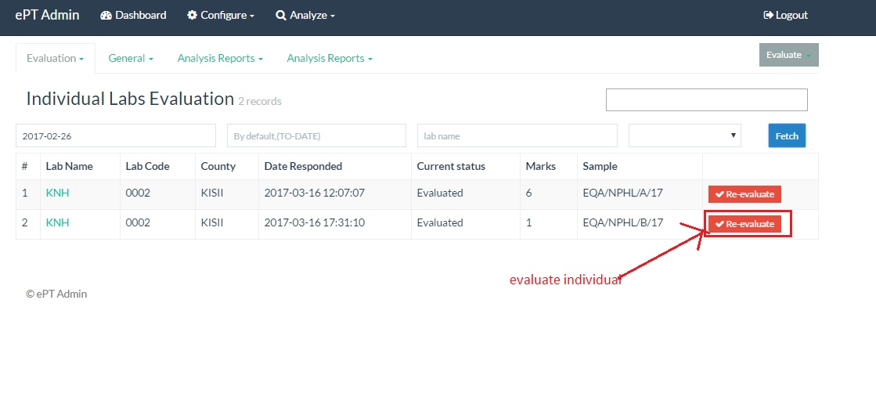

On click the illustrated button above, the below appears where the admin can fill the scores and click save.

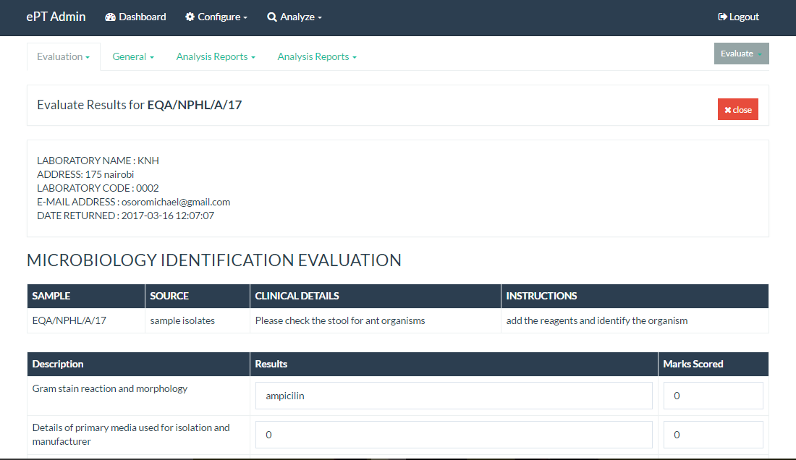

Figure 42

### Publish.

This basically means that the participants can be able to view the results and download the results in pdf format.

On clicking the publishing button every participant will receive a mail.

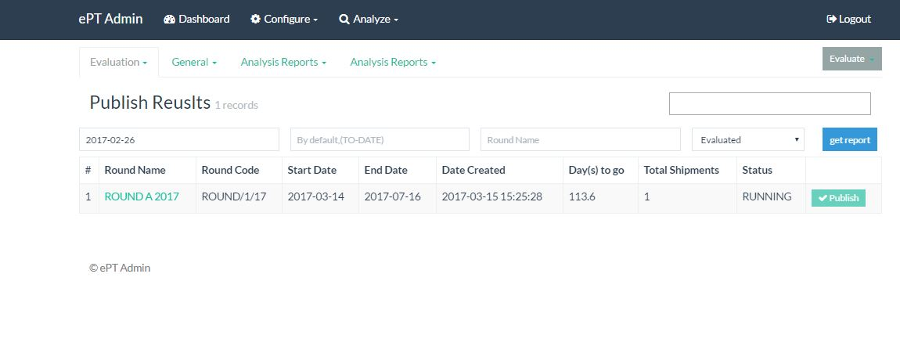

Figure 43

### General

This comprises of 2 reports. They give general statistics on the data

#### Shipment

This reports shows the received, rejected and sent items totals.

The first field is mandatory, how the admin can narrow down the report by search the other fields like round, sample and county

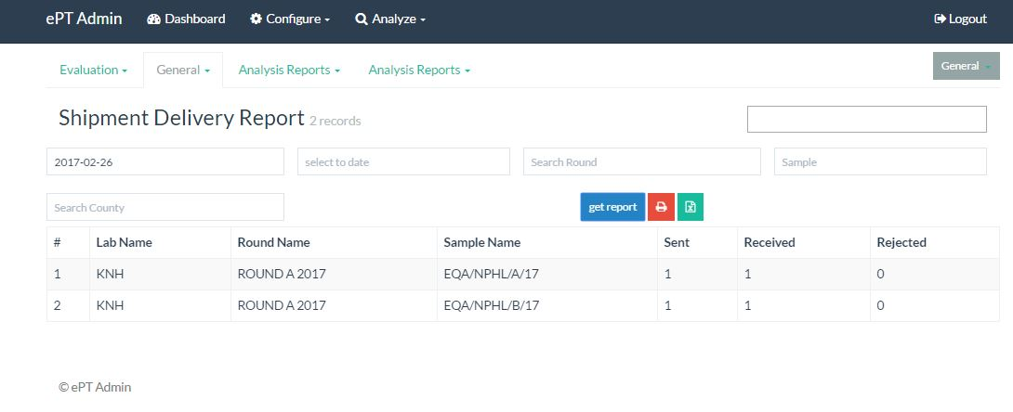

Figure 44

#### Corrective action

This reports those who should take a corrective action, this is done during the evaluation period where the evaluator decides if the participant should or should take the corrective action.

The first field is the one usually mandatory.

Once the report has been generate, pdf and excel options can be used to export the data to respective formats.

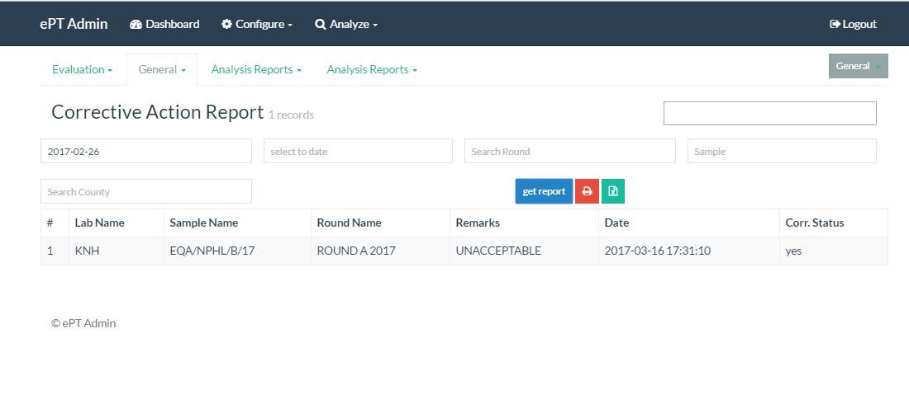

Figure 45

### Analysis.

Show difference performance on lab and round.

#### Laboratory performance report

Show the performance of a labs over a period of times, fine filters can be added to narrow down.

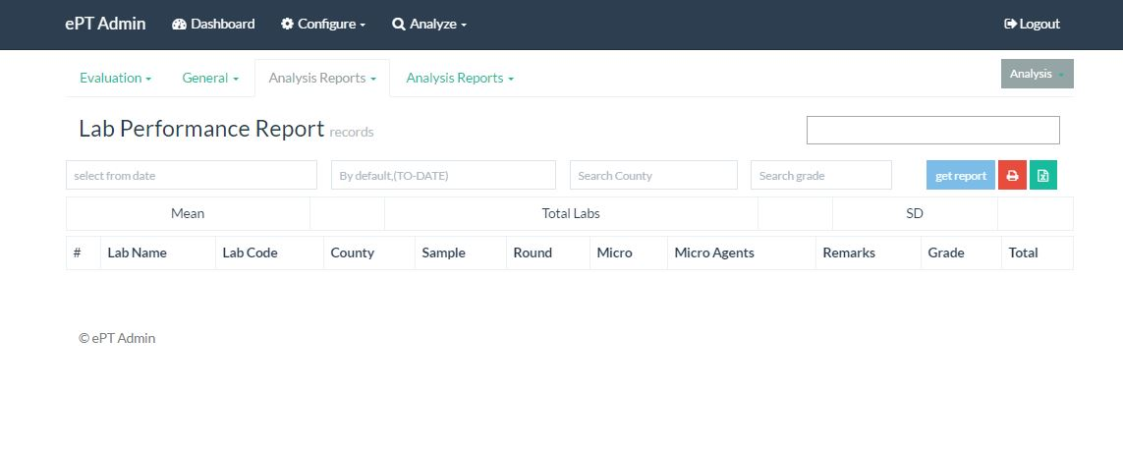

Figure 46

#### Round Performance report.

This report show the lab performance based on the selected fields.

From the analyze tab, click on the Round Performance report.

The first field is always mandatory

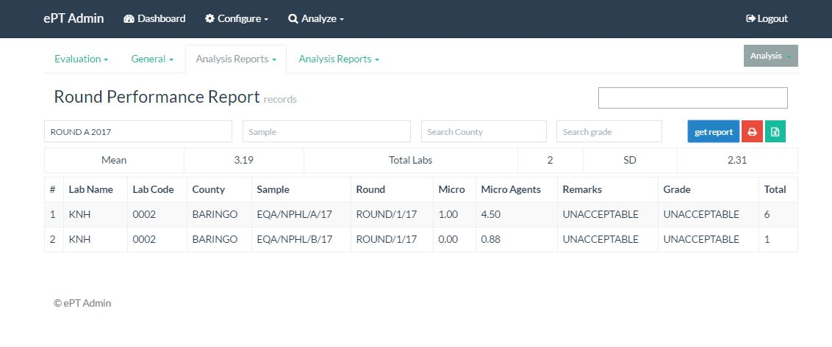

Figure 47

#### Participatory Report.

From the analyze tab, click on the participatory report.

The first field is always mandatory

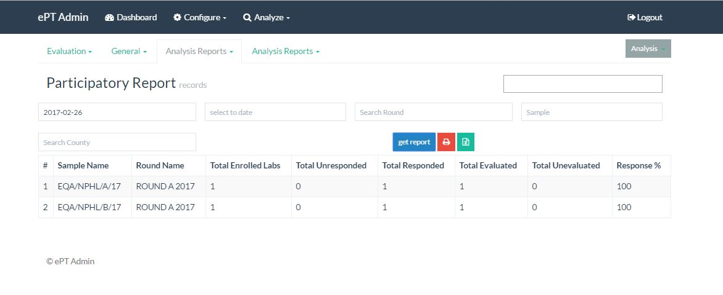

Figure 48

## User/Laboratory Login.

This section is mainly for users in the lab.

### Login Process

For the lab user to be able to access the portal, first the system administrator should have created him/her

Secondly the user should be tied to a lab, however is a user is not tied to a lab, he/she can login in but will not be able to do most of the thing associated with samples and rounds.

He however can be able to edit his/her login details

#### Login

Please enter the username and password as emailed to you by the system, then fill the numbers/letters that appear on the image then click signing

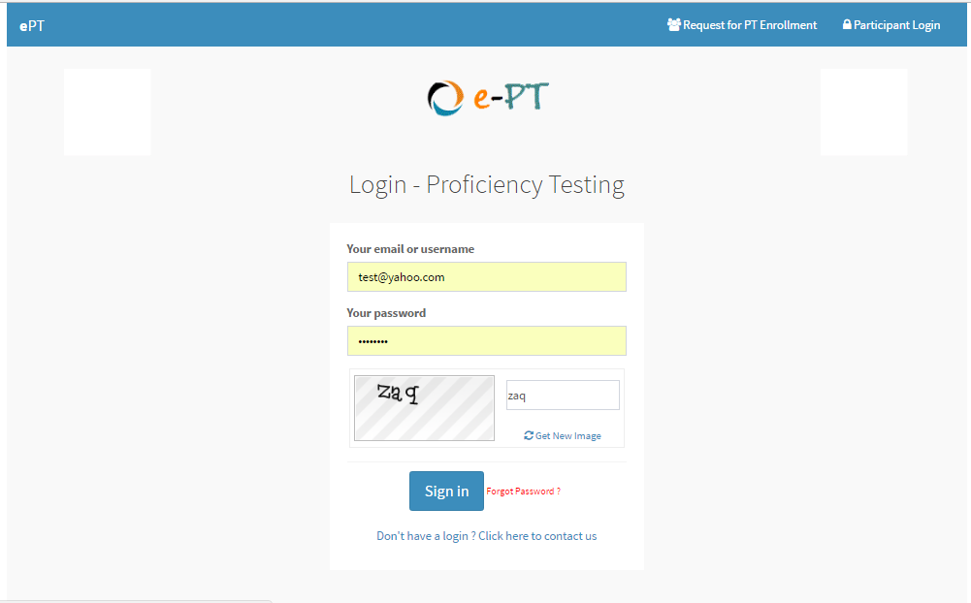

Figure 49

#### Password change

On correct entry of username and password, if it’s the first time you logging in, you will be directed to change password page as below.

Fill in the details and click change password.

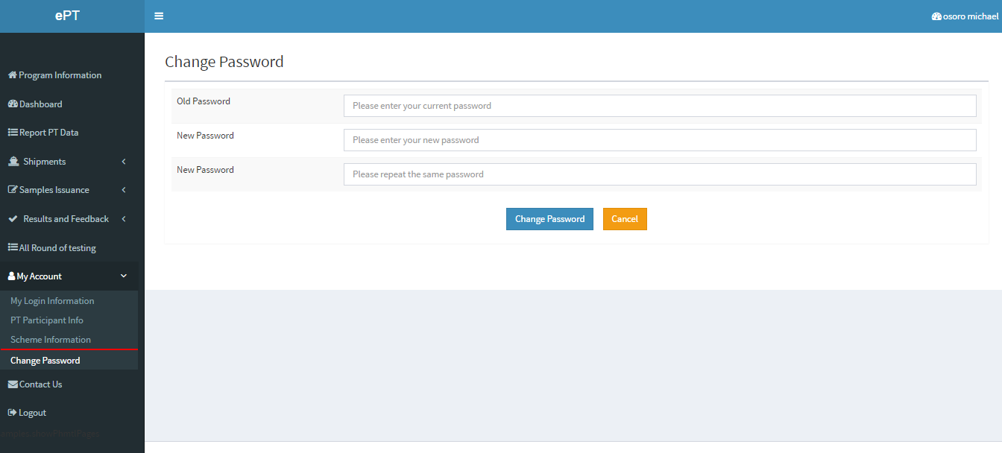

Figure 50

### Dashboard.

To access the dashboard, click dashboard on the left menu and the below page appears.

Dashboard shows 3 things,

* Current round

This show the current running round, if the lab has not enrolled for the round, an enroll button will appear.

If the user wishes to enroll for the current active round, he/she will click on the button and will be prompted to confirm.

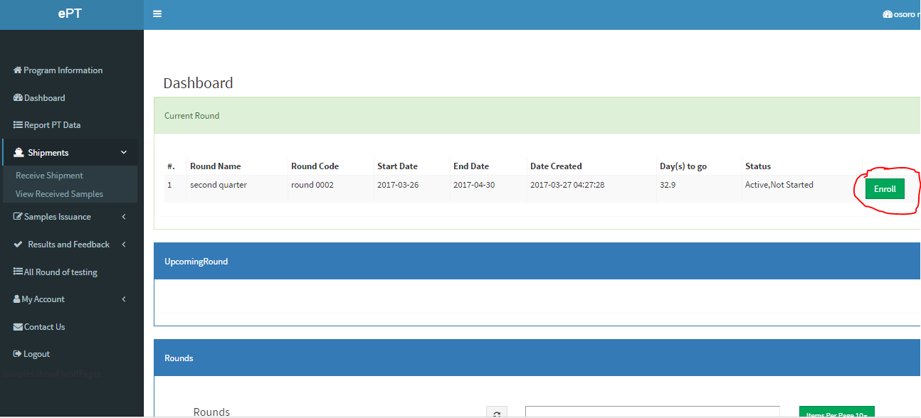

Figure 51

* Upcoming round.

This are upcoming round shown in advance, if they have been created by the admin.

* All rounds

Show all the round that have been created.

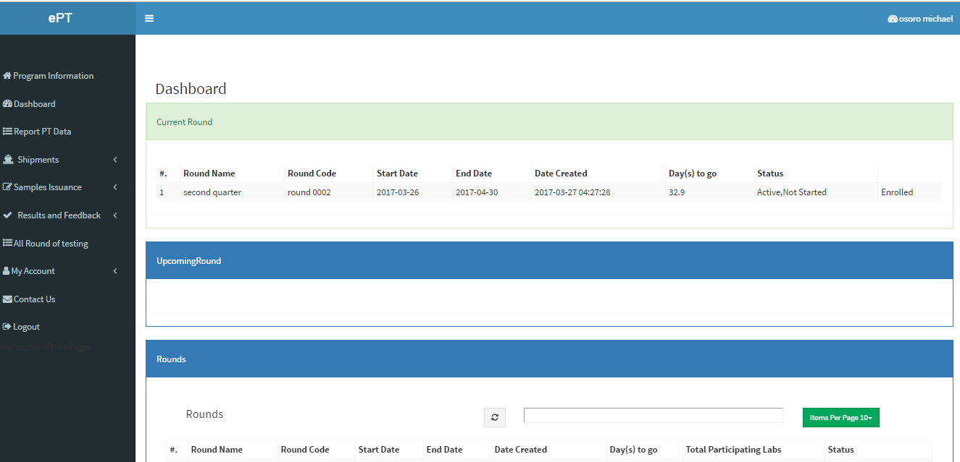

Figure 52

### Shipments.

This section presents where the lab receives and views the samples/shipments sent ate sent from the head office.

#### Receive Shipments.

Click on the shipments menu on the leftbar.on the down drop click on the receive shipment link,beliow page appears.

Click on the refresh button on top of the table,

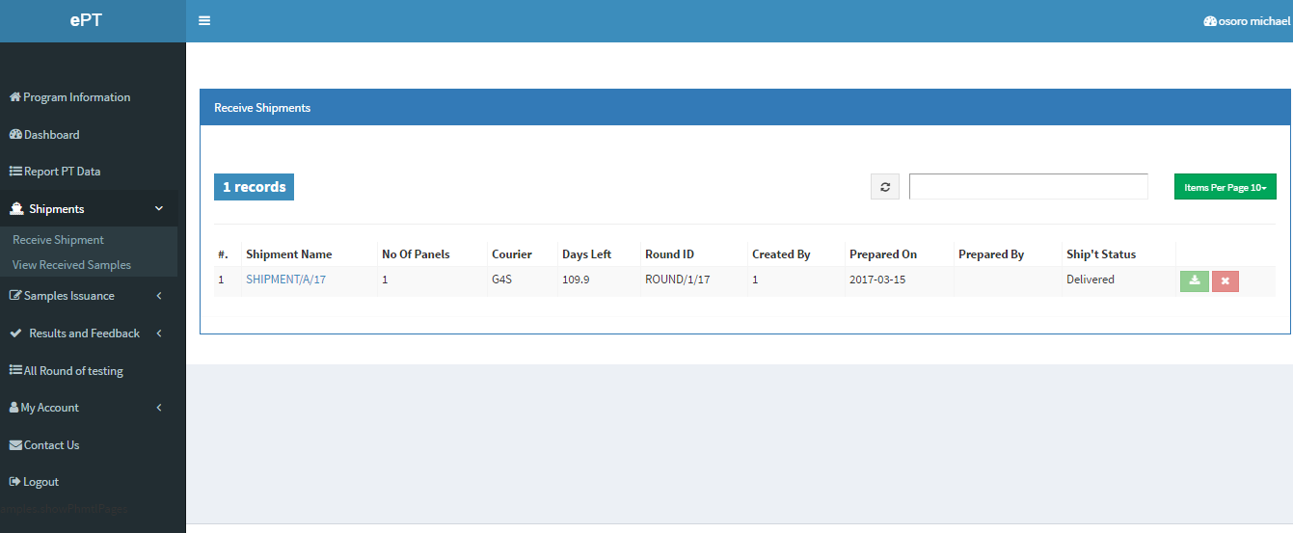

Figure 53

After data is loaded click on  to receive the shipment, a below form appears. Fill in the details and click save receiving shipments.

However, if you don’t wish to receive the shipment for whatever reasons, click on the delete/cancel button, you will be prompted to fill the reasons for doing so.

It’s important to note that you must receive a shipment to be able to use the samples that come with.

Alternatively, the system allows to receive individual packages and individual samples by clicking on the shipment link to access the packages then click on the thumbs up to receive or thumbs down to rejects

Also when the packages appear click on the package link to access the samples in the package,

The click on the tick or delete button to receive and cancel respectively.

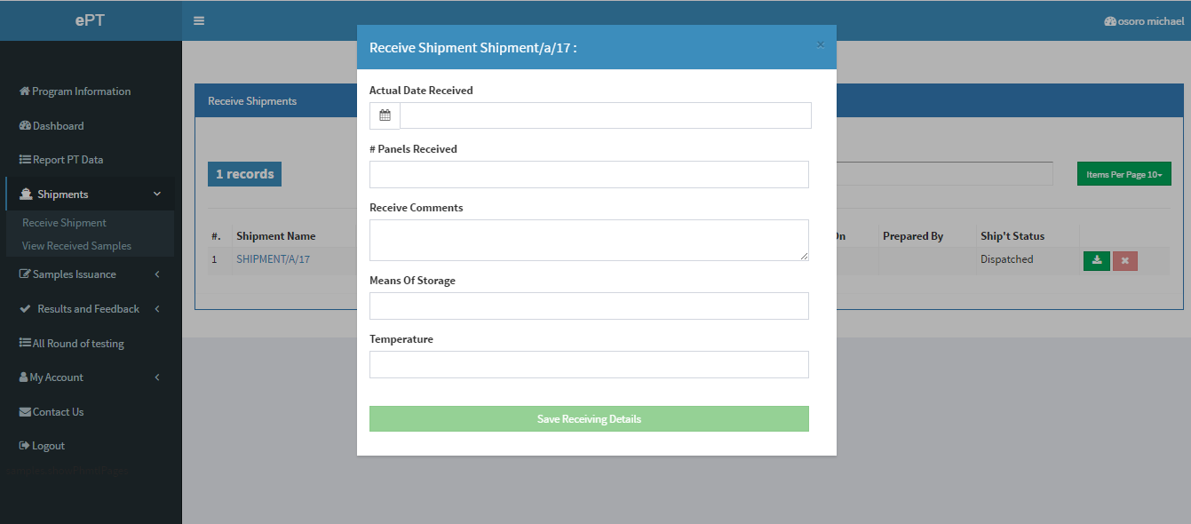

Figure 54

#### Receive panels

The reports show the received panels. Click on the view received panes link.

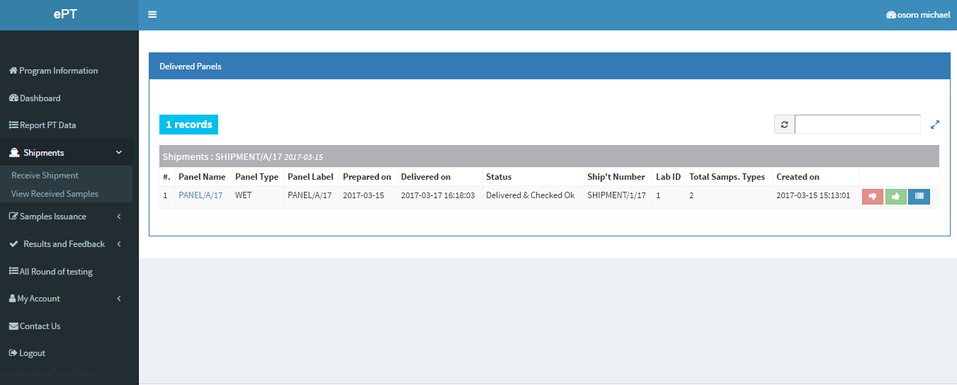

Figure 55

Click on the panel name/label to access the samples inside the panel

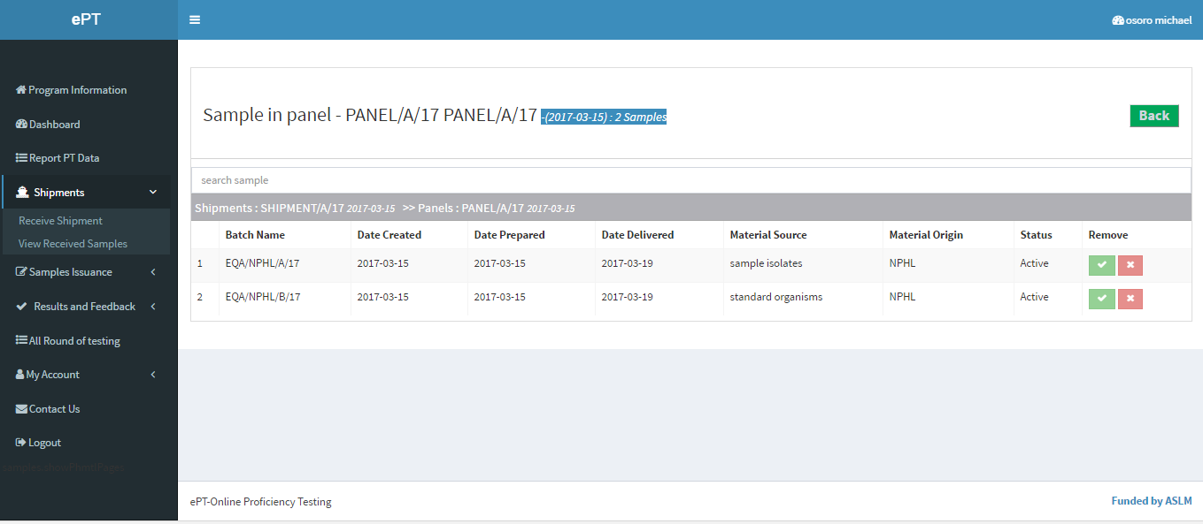

Figure 56

### Sample issuing

This involves issuing samples to users. Click on the samples issuance to load the menus.

#### Issue samples.

Once the samples have been received, they can then be issued to the technicians inside the labs.

Click on the refresh button, once the samples appear click on the issue button.

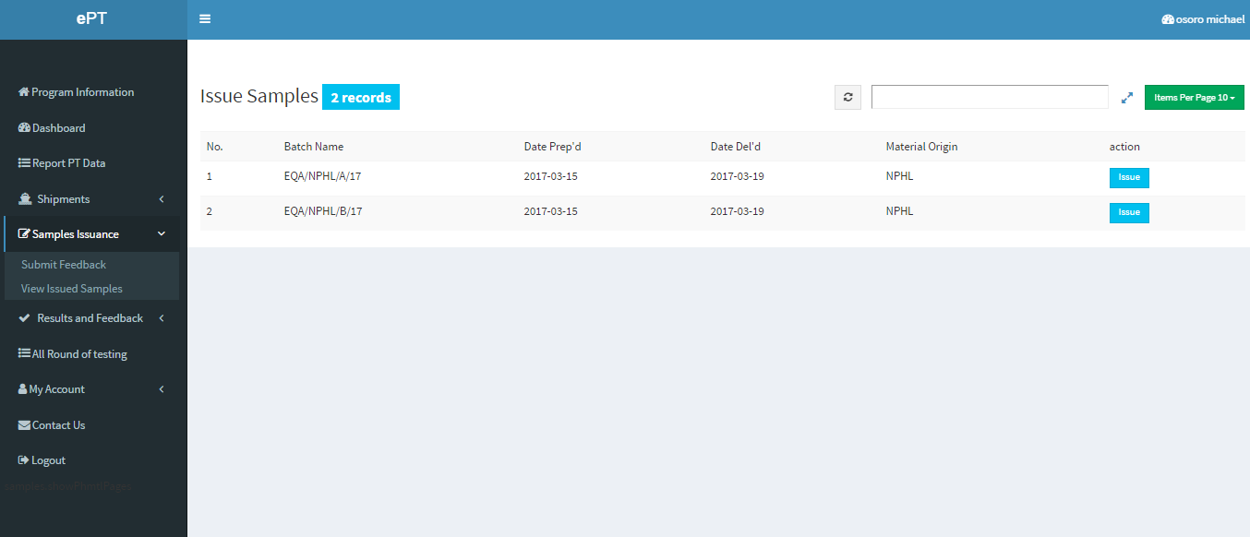

Figure 57

On click the issue button the below appears, tick the users you want to participant on the round and click save.

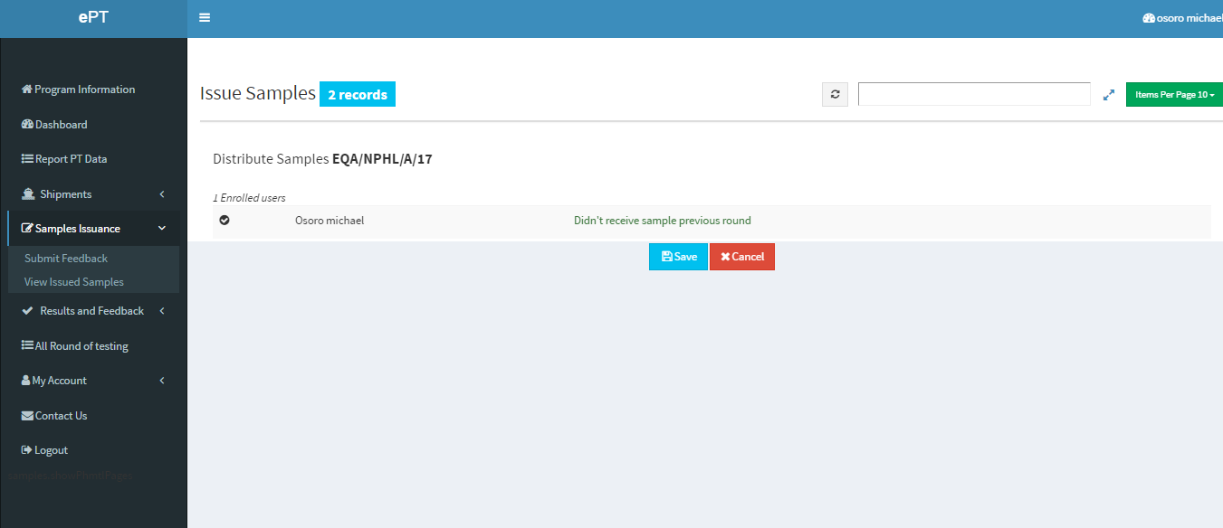

Figure 58

* + 1. View Issued samples.

Show the samples issued to users.

Click on the View issued samples inside the samples issuance menu.

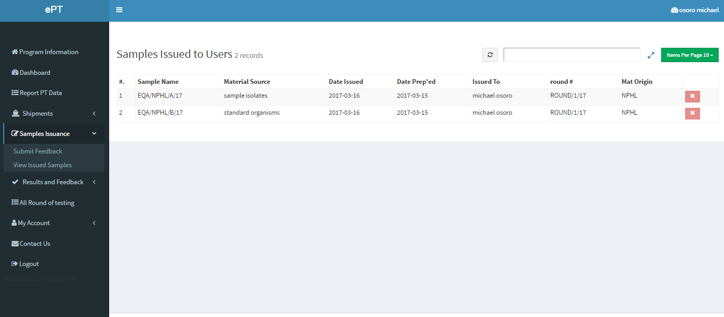

Figure 59

### Results

This section the user gets to give feedback on the results and view the evaluated tests.

Click on the results and feedback.

#### Respond to results.

On the drop menus, click on submit feedback. On the page that appears click on the refresh button to load data.

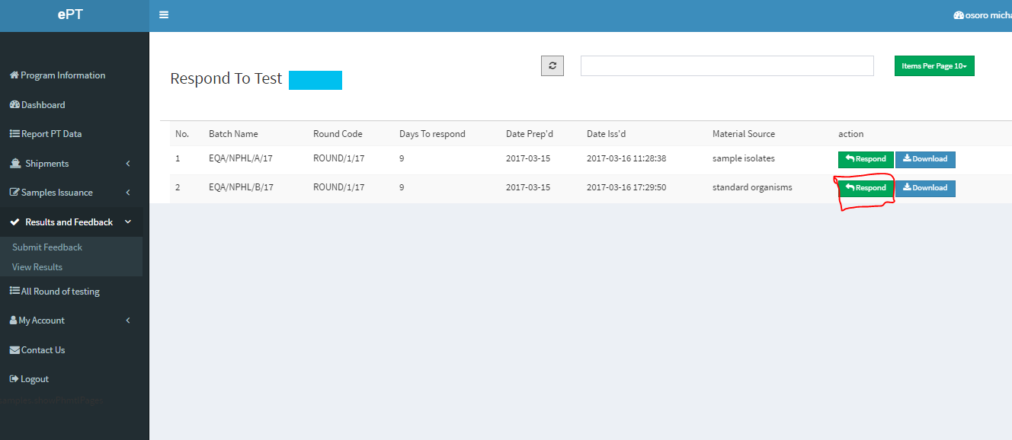

Figure 60

Below form for feeding the feedback appears.

Fill the results and click the button at the end of each form. If any of the form is skipped, it will be assumed you didn’t submit and a 0 score will be awarded.

It’s important to note the sample instruction appear before the forms to enter data.

Read the instructions very carefully before submitting the results.

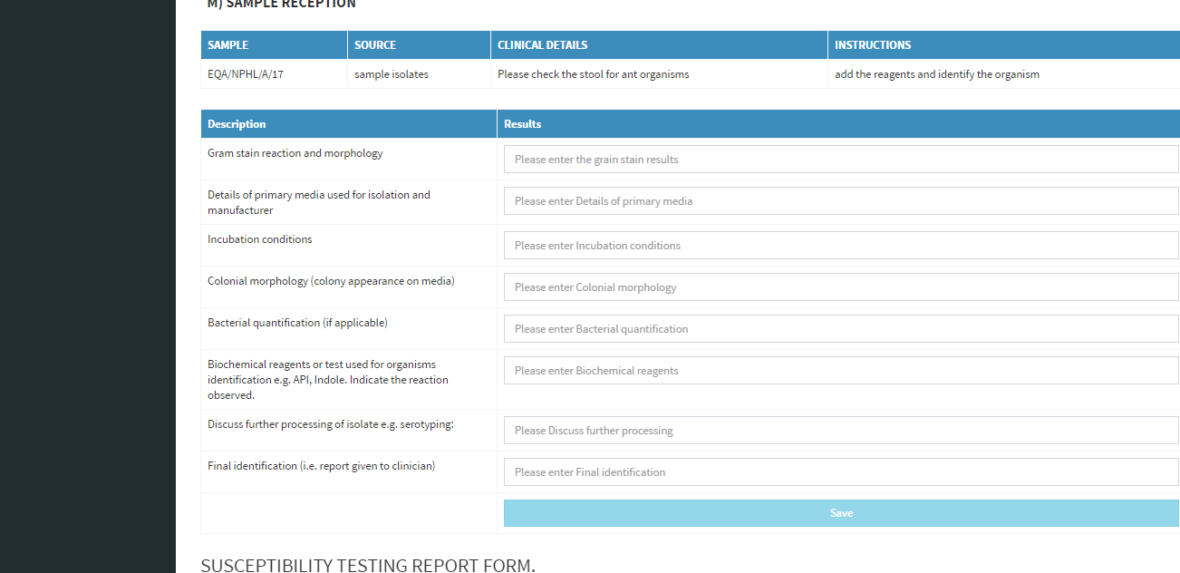

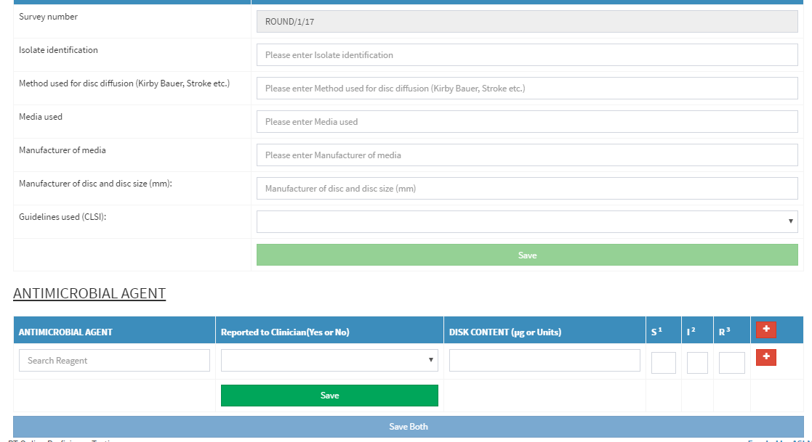

Once data has been entered, you can still be able to edit the data by clicking on the edit button.

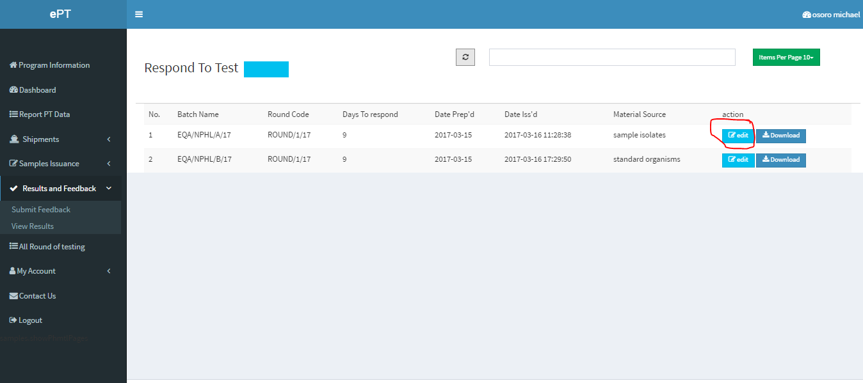

#### View results

Click on the view results, select the date from, or the range you wish to view the results and click get report.

Data will appear grouped round wise with sample, click on the view button to view the comprehensive report on performance of the sample

You can also click on the print button to download a pdf to print pdf .

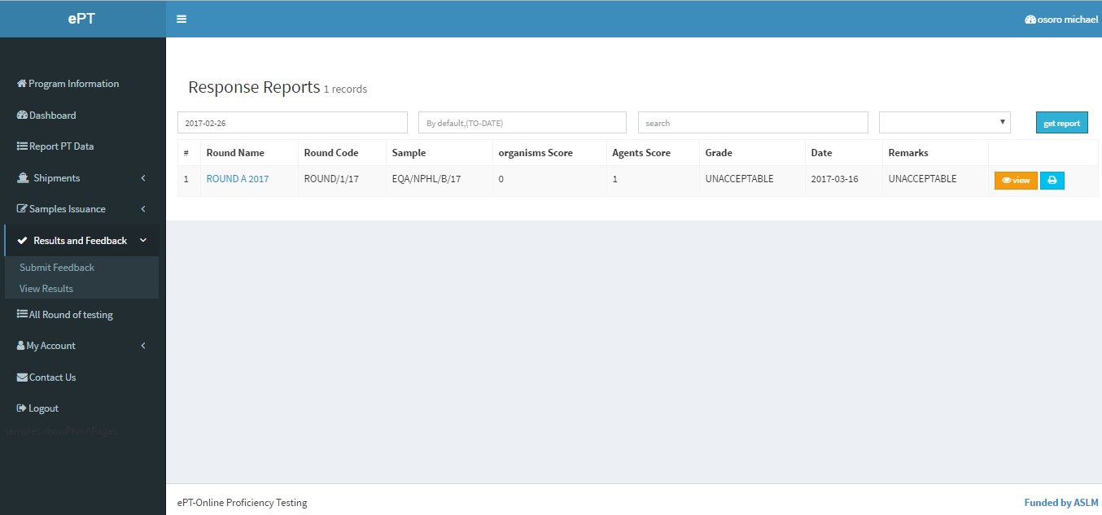

Click on the view button open the below page

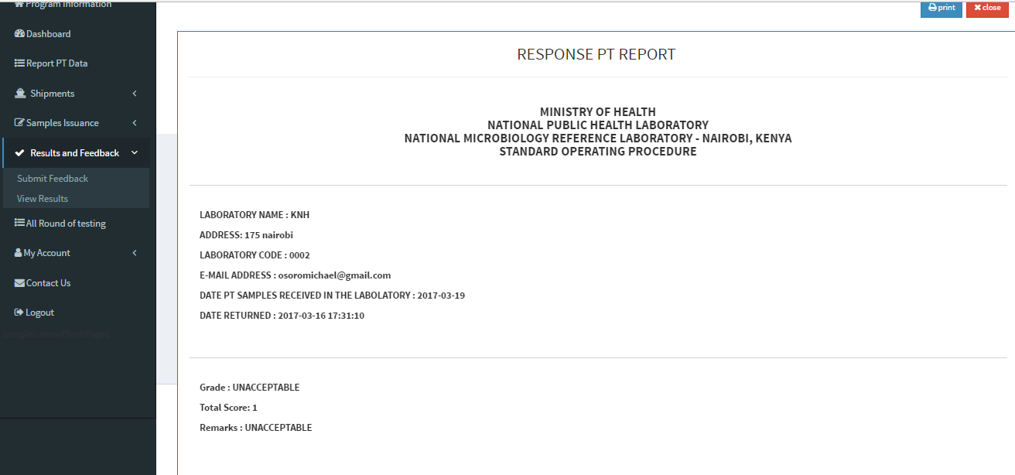

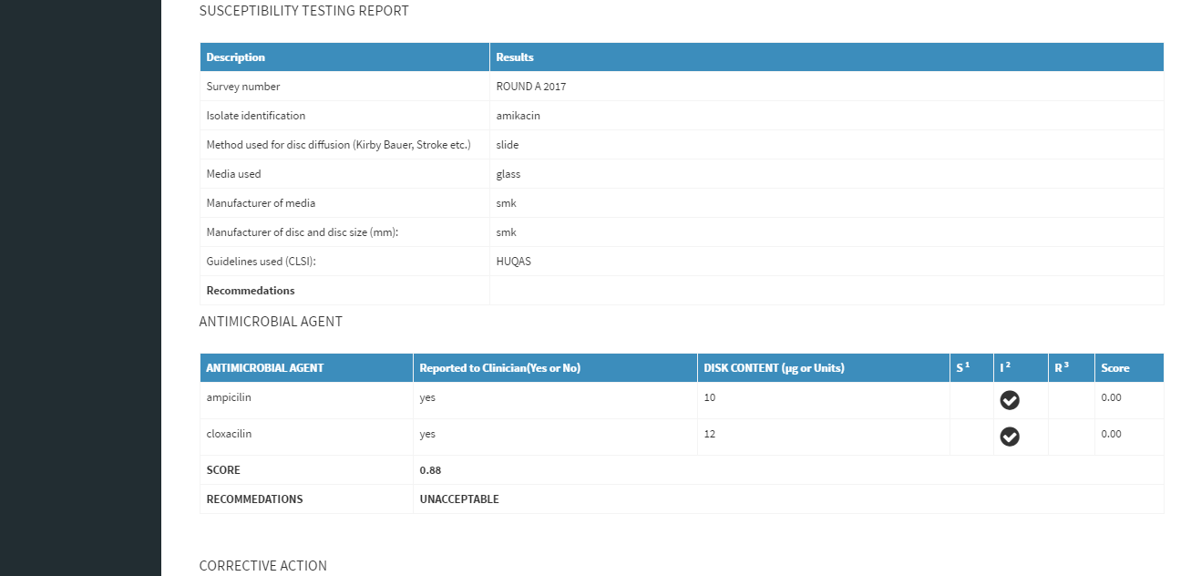

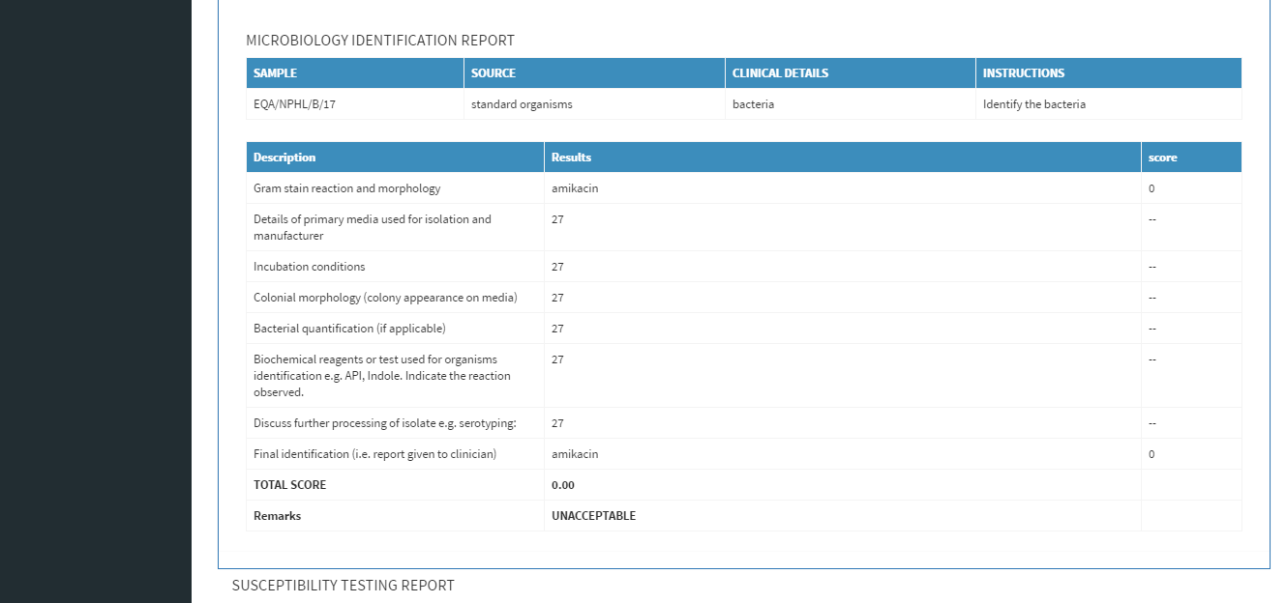

#### Download/print

### My account

This section presents account editing.

Click on My Account link on the left side of the page.

#### My Login Info

To edit log in info, click on My Login Information. Edit the detail and click submit

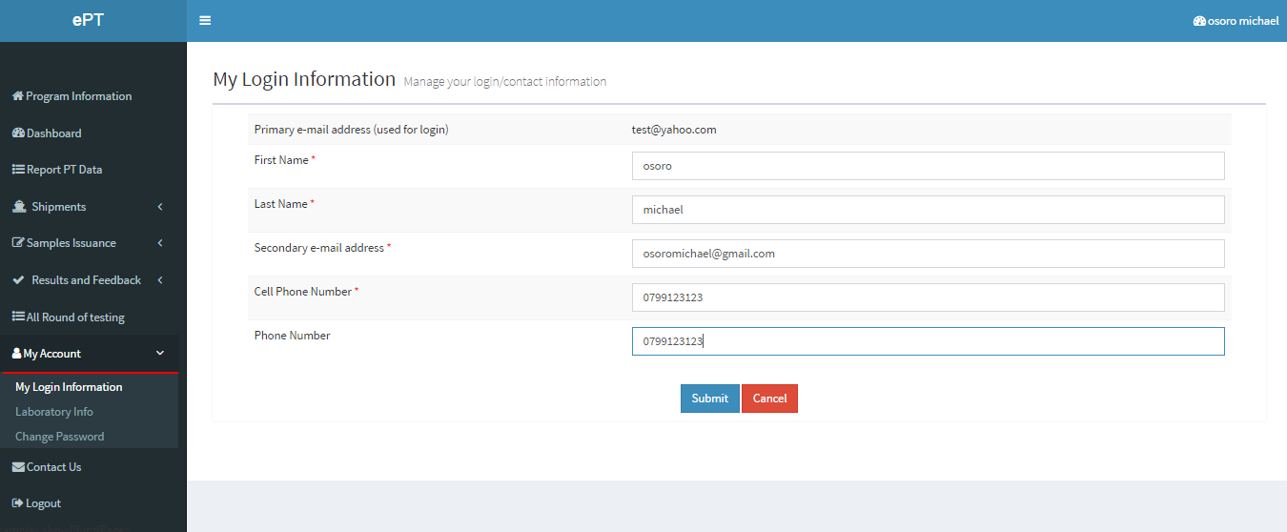

#### My Laboratory Info.

Click on laboratory information, and the lab you current attached to will appear.

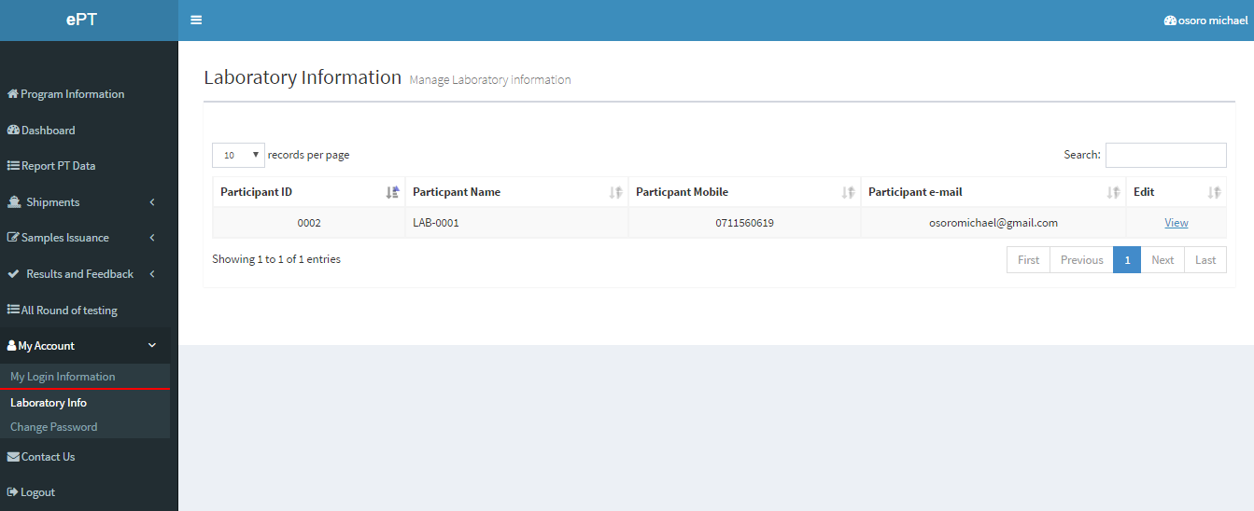

#### Change password

To change a password, just click on the change password link and the change password form appears

### Logout

On the left sidebar, click on logout.